**THỰC HÀNH BUỔI 2 (Máy 17)**

Nguyễn Dương Quốc Huy

1150070017

**LAB 3**

**Luyện tập 1: truyện cười:**

AndroidManifest:

<?xml version="1.0" encoding="utf-8"?>  
<manifest xmlns:android="http://schemas.android.com/apk/res/android"  
 package="com.example.nguyenduongquochuylab3">  
  
 <application  
 android:allowBackup="true"  
 android:icon="@mipmap/ic_launcher"  
 android:label="Truyện cười"  
 android:roundIcon="@mipmap/ic_launcher_round"  
 android:supportsRtl="true"  
 android:theme="@style/Theme.TruyenCuoi">  
 <activity  
 android:name=".ui.JokeDetailActivity"  
 android:exported="false"  
 android:parentActivityName=".ui.JokeListActivity" />  
 <activity  
 android:name=".ui.JokeListActivity"  
 android:exported="false"  
 android:parentActivityName=".ui.MainActivity" />  
 <activity  
 android:name=".ui.MainActivity"  
 android:exported="false" />  
 <activity  
 android:name=".ui.SplashActivity"  
 android:exported="true">  
 <intent-filter>  
 <action android:name="android.intent.action.MAIN" />  
 <category android:name="android.intent.category.LAUNCHER" />  
 </intent-filter>  
 </activity>  
 </application>  
  
</manifest>

CategoryAdapter:

<?xml version="1.0" encoding="utf-8"?>  
<manifest xmlns:android="http://schemas.android.com/apk/res/android"  
 package="com.example.nguyenduongquochuylab3">  
  
 <application  
 android:allowBackup="true"  
 android:icon="@mipmap/ic_launcher"  
 android:label="Truyện cười"  
 android:roundIcon="@mipmap/ic_launcher_round"  
 android:supportsRtl="true"  
 android:theme="@style/Theme.TruyenCuoi">  
 <activity  
 android:name=".ui.JokeDetailActivity"  
 android:exported="false"  
 android:parentActivityName=".ui.JokeListActivity" />  
 <activity  
 android:name=".ui.JokeListActivity"  
 android:exported="false"  
 android:parentActivityName=".ui.MainActivity" />  
 <activity  
 android:name=".ui.MainActivity"  
 android:exported="false" />  
 <activity  
 android:name=".ui.SplashActivity"  
 android:exported="true">  
 <intent-filter>  
 <action android:name="android.intent.action.MAIN" />  
 <category android:name="android.intent.category.LAUNCHER" />  
 </intent-filter>  
 </activity>  
 </application>  
  
</manifest>

JokeAdapter:

package com.example.nguyenduongquochuylab3.adapter;  
  
import android.view.LayoutInflater;  
import android.view.View;  
import android.view.ViewGroup;  
import android.widget.TextView;  
import androidx.annotation.NonNull;  
import androidx.recyclerview.widget.RecyclerView;  
import com.example.nguyenduongquochuylab3.R;  
import com.example.nguyenduongquochuylab3.data.Joke;  
import java.util.List;  
  
public class JokeAdapter extends RecyclerView.Adapter<JokeAdapter.VH> {  
  
 public interface OnJokeClick { void onClick(Joke j); }  
  
 private final List<Joke> items;  
 private final OnJokeClick listener;  
  
 public JokeAdapter(List<Joke> items, OnJokeClick l) {  
 this.items = items; this.listener = l;  
 }  
  
 @NonNull @Override public VH onCreateViewHolder(@NonNull ViewGroup parent, int viewType) {  
 View v = LayoutInflater.*from*(parent.getContext()).inflate(R.layout.*item_joke*, parent, false);  
 return new VH(v);  
 }  
  
 @Override public void onBindViewHolder(@NonNull VH h, int position) {  
 Joke j = items.get(position);  
 h.title.setText(j.title);  
 h.itemView.setOnClickListener(v -> listener.onClick(j));  
 }  
  
 @Override public int getItemCount() { return items.size(); }  
  
 static class VH extends RecyclerView.ViewHolder {  
 TextView title;  
 VH(@NonNull View v) { super(v); title = v.findViewById(R.id.*tvJokeTitle*); }  
 }  
}

Category:

package com.example.nguyenduongquochuylab3.data;  
  
public class Category {  
 public final int id;  
 public final String title;  
 public final int iconRes;  
  
 public Category(int id, String title, int iconRes) {  
 this.id = id; this.title = title; this.iconRes = iconRes;  
 }  
}

DataProvider:

package com.example.nguyenduongquochuylab3.data;  
  
import com.example.nguyenduongquochuylab3.R;  
import java.util.*;  
  
public class DataProvider {  
  
 public static List<Category> getCategories() {  
 List<Category> out = new ArrayList<>();  
 out.add(new Category(1, "Con gái", R.drawable.*ic_cat_girl*));  
 out.add(new Category(2, "Công sở", R.drawable.*ic_cat_work*));  
 out.add(new Category(3, "Cực hài", R.drawable.*ic_cat_fun*));  
 out.add(new Category(4, "Dân gian", R.drawable.*ic_cat_folk*));  
 out.add(new Category(5, "Gia đình", R.drawable.*ic_cat_family*));  
 out.add(new Category(6, "Giao thông", R.drawable.*ic_cat_transport*));  
 out.add(new Category(7, "Học sinh", R.drawable.*ic_cat_student*));  
 return out;  
 }  
  
 public static List<Joke> getJokes(int catId) {  
 // Demo data – mỗi danh mục 10 truyện ngắn  
 List<Joke> list = new ArrayList<>();  
 switch (catId) {  
 case 1: // Con gái  
 list.add(new Joke("Việc học", "Lúc bé, một học trò kể chuyện:\nLớn lên mới biết, chuyện là do mẹ.\nLúc bé: thích được mẹ dẫn tới trường.\nLớn lên: thích mẹ đứng ngoài cổng.\nBiết chữ rồi: thích nghỉ học...\nLớn lên nữa: biết đi làm mới nhớ..."));  
 list.add(new Joke("Đã lớn rồi", "Cô gái bảo mẹ: Con lớn rồi. Mẹ: Ừ, lớn thì rửa chén giùm mẹ nhé! – Con vẫn còn nhỏ mà mẹ!"));  
 list.add(new Joke("Cũng như nhau", "Bạn gái hỏi: Anh thích em vì điều gì? – Vì em xinh. – Nếu em xấu thì? – Thì cũng như nhau thôi, vì khi yêu sẽ thấy xinh!"));  
 list.add(new Joke("Rất lạnh", "Trời lạnh. Cô: Anh ôm em cho ấm. Anh: Ở gần tim anh luôn ấm!"));  
 list.add(new Joke("Im lặng là vàng", "Cãi nhau mệt, cô nói: Im lặng là vàng. Chàng: Anh đang giữ vàng đây!"));  
 list.add(new Joke("Bài học vỡ lòng", "Cô dạy bé: Con gái là phải dịu dàng. Bé trai: Thế con trai là phải nhường!"));  
 list.add(new Joke("Chưa chà chứ đau", "Cô than: Vết thương lòng chưa chà đã đau. Anh: Để anh chà nhẹ..."));  
 list.add(new Joke("1 xu và 1 phút", "Một xu và một phút – cái nào dài hơn? Đáp: Một phút vì trong ví hết xu nhưng thời gian vẫn còn!"));  
 list.add(new Joke("Sao con chưa thả?", "Mẹ: Áo mới đẹp không? Con: Đẹp! – Sao con chưa thả tim? Con: Ở ngoài đời con thả nụ cười!"));  
 list.add(new Joke("Cảm giác", "Cảm giác ăn hết nồi bánh chưng là thấy Tết đến rồi!"));  
 break;  
  
 case 2: // Công sở  
 list.add(new Joke("Báo cáo ngắn gọn", "Sếp: Báo cáo phải ngắn. Nhân viên: Dạ, công việc: nhiều. Kết quả: đang làm."));  
 list.add(new Joke("Đi trễ", "Hỏi: Sao anh đi trễ? – Vì em đồng hồ nhanh! – Đồng hồ nhanh sao trễ? – Em ngủ nướng!"));  
 list.add(new Joke("Họp online", "Camera tắt, mic tắt. Sếp: Còn ai ở đó không? – Dạ có em và... con mèo!"));  
 list.add(new Joke("Deadline", "Deadline như chiếc xe bus, trễ một lần là muốn bám đuôi cả tháng."));  
 list.add(new Joke("Email", "Gửi nhầm email cho sếp, tốc độ tắt wifi đạt chuẩn Olympic."));  
 list.add(new Joke("Cà phê công sở", "Họp 9 giờ, 9 rưỡi mới xong pha cà phê."));  
 list.add(new Joke("Làm từ xa", "Làm từ xa: xa bàn làm việc nhất có thể."));  
 list.add(new Joke("Sinh nhật", "Sinh nhật phòng ban: ăn bánh nhiều hơn kế hoạch."));  
 list.add(new Joke("Văn hoá thumbs-up", "Reply ‘👍’ là đã hoàn thành 80% nhiệm vụ giao tiếp."));  
 list.add(new Joke("Xin nghỉ", "Lý do xin nghỉ: trời mưa – kẹt trong chiếc chăn."));  
 break;  
  
 case 3: // Cực hài  
 for (int i = 1; i <= 10; i++)  
 list.add(new Joke("Câu chuyện cười " + i, "Một ngày đẹp trời... và chiếc bụng cười lăn."));  
 break;  
  
 case 4: // Dân gian  
 list.add(new Joke("Thần đèn", "Ước gì? – Ước thêm ước nữa!"));  
 list.add(new Joke("Cây khế", "Ăn khế trả vàng, trả vàng trả lại nụ cười."));  
 // … thêm vài câu  
 for (int i=3;i<=10;i++) list.add(new Joke("Giai thoại dân gian " + i, "Kể chuyện xưa mà mới."));  
 break;  
  
 case 5: // Gia đình  
 list.add(new Joke("Cơm nhà", "Ba: Cơm ngon không? Con: Con chỉ thấy ngon khi mẹ nấu ạ!"));  
 for (int i=2;i<=10;i++) list.add(new Joke("Chuyện nhà " + i, "Nhà là nơi cười nhiều nhất."));  
 break;  
  
 case 6: // Giao thông  
 for (int i=1;i<=10;i++) list.add(new Joke("Chuyện đường " + i, "Kẹt xe nhưng không kẹt tiếng cười."));  
 break;  
  
 case 7: // Học sinh  
 list.add(new Joke("Kiểm tra miệng", "Cô: Em thuộc bài chưa? – Dạ thuộc ạ, nhưng ở nhà."));  
 list.add(new Joke("Nghỉ học", "Trời mưa to, học sinh: Chúng em học cách chống nước!"));  
 for (int i=3;i<=10;i++) list.add(new Joke("Chuyện lớp " + i, "Nhất quỷ, nhì ma, thứ ba học trò."));  
 break;  
 }  
 return list;  
 }  
}

Joke:

package com.example.nguyenduongquochuylab3.data;  
  
public class Joke {  
 public final String title;  
 public final String content;  
  
 public Joke(String title, String content) {  
 this.title = title; this.content = content;  
 }  
}

JokeDetailActivity:

package com.example.nguyenduongquochuylab3.ui;  
  
import android.os.Bundle;  
import androidx.appcompat.app.AppCompatActivity;  
import androidx.appcompat.widget.Toolbar;  
import android.widget.TextView;  
import com.example.nguyenduongquochuylab3.R;  
  
public class JokeDetailActivity extends AppCompatActivity {  
 @Override protected void onCreate(Bundle savedInstanceState) {  
 super.onCreate(savedInstanceState);  
 setContentView(R.layout.*activity_joke_detail*);  
  
 String title = getIntent().getStringExtra("title");  
 String content = getIntent().getStringExtra("content");  
  
 Toolbar tb = findViewById(R.id.*toolbar*);  
 tb.setTitle(title);  
 setSupportActionBar(tb);  
 tb.setNavigationOnClickListener(v -> onBackPressed());  
  
 TextView tv = findViewById(R.id.*tvContent*);  
 tv.setText(content);  
 }  
}

JokeListActivity:

package com.example.nguyenduongquochuylab3.ui;  
  
import android.content.Intent;  
import android.os.Bundle;  
import androidx.appcompat.app.AppCompatActivity;  
import androidx.appcompat.widget.Toolbar;  
import androidx.recyclerview.widget.DividerItemDecoration;  
import androidx.recyclerview.widget.LinearLayoutManager;  
import androidx.recyclerview.widget.RecyclerView;  
import com.example.nguyenduongquochuylab3.R;  
import com.example.nguyenduongquochuylab3.adapter.JokeAdapter;  
import com.example.nguyenduongquochuylab3.data.DataProvider;  
import com.example.nguyenduongquochuylab3.data.Joke;  
  
public class JokeListActivity extends AppCompatActivity implements JokeAdapter.OnJokeClick {  
 int catId;  
 @Override protected void onCreate(Bundle savedInstanceState) {  
 super.onCreate(savedInstanceState);  
 setContentView(R.layout.*activity_joke_list*);  
  
 catId = getIntent().getIntExtra("catId", 0);  
 String name = getIntent().getStringExtra("catName");  
  
 Toolbar tb = findViewById(R.id.*toolbar*);  
 tb.setTitle(name);  
 setSupportActionBar(tb);  
 tb.setNavigationOnClickListener(v -> onBackPressed());  
  
 RecyclerView rv = findViewById(R.id.*rvJokes*);  
 rv.setLayoutManager(new LinearLayoutManager(this));  
 rv.addItemDecoration(new DividerItemDecoration(this, DividerItemDecoration.*VERTICAL*));  
 JokeAdapter ad = new JokeAdapter(DataProvider.*getJokes*(catId), this);  
 rv.setAdapter(ad);  
 }  
  
 @Override public void onClick(Joke j) {  
 Intent i = new Intent(this, JokeDetailActivity.class);  
 i.putExtra("title", j.title);  
 i.putExtra("content", j.content);  
 startActivity(i);  
 }  
}

MainActivity:

package com.example.nguyenduongquochuylab3.ui;  
  
import android.content.Intent;  
import android.os.Bundle;  
import androidx.appcompat.app.AppCompatActivity;  
import androidx.appcompat.widget.Toolbar;  
import androidx.recyclerview.widget.LinearLayoutManager;  
import androidx.recyclerview.widget.RecyclerView;  
import com.example.nguyenduongquochuylab3.R;  
import com.example.nguyenduongquochuylab3.adapter.CategoryAdapter;  
import com.example.nguyenduongquochuylab3.data.Category;  
import com.example.nguyenduongquochuylab3.data.DataProvider;  
  
public class MainActivity extends AppCompatActivity implements CategoryAdapter.OnCategoryClick {  
 @Override protected void onCreate(Bundle savedInstanceState) {  
 super.onCreate(savedInstanceState);  
 setContentView(R.layout.*activity_main*);  
  
 Toolbar tb = findViewById(R.id.*toolbar*);  
 tb.setTitle("Truyện cười");  
 setSupportActionBar(tb);  
  
 RecyclerView rv = findViewById(R.id.*rvCategories*);  
 rv.setLayoutManager(new LinearLayoutManager(this));  
 CategoryAdapter ad = new CategoryAdapter(DataProvider.*getCategories*(), this);  
 rv.setAdapter(ad);  
 }  
  
 @Override public void onClick(Category c) {  
 Intent i = new Intent(this, JokeListActivity.class);  
 i.putExtra("catId", c.id);  
 i.putExtra("catName", c.title);  
 startActivity(i);  
 }  
}

SplashActivity:

package com.example.nguyenduongquochuylab3.ui;  
  
import android.content.Intent;  
import android.os.Bundle;  
import android.os.Handler;  
import androidx.appcompat.app.AppCompatActivity;  
import com.example.nguyenduongquochuylab3.R;  
  
public class SplashActivity extends AppCompatActivity {  
 @Override protected void onCreate(Bundle savedInstanceState) {  
 super.onCreate(savedInstanceState);  
 setContentView(R.layout.*activity_splash*);  
 new Handler().postDelayed(() ->  
 startActivity(new Intent(this, MainActivity.class)), 1200);  
 }  
 @Override protected void onPause() { super.onPause(); finish(); }  
}

Trong drawable

bg_splash:

<?xml version="1.0" encoding="utf-8"?>  
<shape xmlns:android="http://schemas.android.com/apk/res/android" android:shape="rectangle">  
 <solid android:color="@color/green_600" />  
</shape>

ic_cat_family:

<vector xmlns:android="http://schemas.android.com/apk/res/android"  
 android:width="24dp" android:height="24dp" android:viewportWidth="24" android:viewportHeight="24">  
 <path android:fillColor="#FFFFFFFF" android:pathData="M16.5,13c1.38,0 2.5,-1.12 2.5,-2.5S17.88,8 16.5,8 14,9.12 14,10.5s1.12,2.5 2.5,2.5zM9,12c1.66,0 3,-1.34 3,-3S10.66,6 9,6 6,7.34 6,9s1.34,3 3,3zM16.5,15c-1.83,0 -5.5,0.92 -5.5,2.75V21h11v-3.25C22,15.92 18.33,15 16.5,15zM9,14c-2.33,0 -7,1.17 -7,3.5V21h7v-3h2v3h7v-3.5C18,15.17 13.33,14 11,14H9z"/>  
</vector>

ic_cat_folk:

<vector xmlns:android="http://schemas.android.com/apk/res/android"  
 android:width="24dp" android:height="24dp" android:viewportWidth="24" android:viewportHeight="24">  
 <path android:fillColor="#FFFFFFFF" android:pathData="M12,2L2,7l10,5 10,-5 -10,-5zM2,17l10,5 10,-5M2,12l10,5 10,-5"/>  
</vector>

ic_cat_fun:

<vector xmlns:android="http://schemas.android.com/apk/res/android"  
 android:width="24dp" android:height="24dp" android:viewportWidth="24" android:viewportHeight="24">  
 <path android:fillColor="#FFFFFFFF" android:pathData="M11.99,2C6.47,2 2,6.48 2,12s4.47,10 9.99,10C17.52,22 22,17.52 22,12S17.52,2 11.99,2zM7,9h2v2H7V9zm8,0h2v2h-2V9zM12,18c-2.33,0 -4.31,-1.46 -5.11,-3.5h10.22C16.31,16.54 14.33,18 12,18z"/>  
</vector>

ic_cat_girl:

<vector xmlns:android="http://schemas.android.com/apk/res/android"  
 android:width="24dp" android:height="24dp" android:viewportWidth="24" android:viewportHeight="24">  
 <path android:fillColor="#FFFFFFFF" android:pathData="M12,4a4,4 0,1 1,0 8,4 4,0 1,1 0,-8zM6,20c0,-3.31 2.69,-6 6,-6s6,2.69 6,6H6z"/>  
</vector>

ic_cat_student:

<vector xmlns:android="http://schemas.android.com/apk/res/android"  
 android:width="24dp" android:height="24dp" android:viewportWidth="24" android:viewportHeight="24">  
 <path android:fillColor="#FFFFFFFF" android:pathData="M12,3L1,9l11,6 9,-4.91V17h2V9L12,3zM3.18,9L12,4.44 20.82,9 12,13.56 3.18,9zM12,15l-7,-3.73V17c0,2.21 3.58,4 8,4s8,-1.79 8,-4v-5.73L12,15z"/>  
</vector>

ic_cat_transport:

<vector xmlns:android="http://schemas.android.com/apk/res/android"  
 android:width="24dp" android:height="24dp" android:viewportWidth="24" android:viewportHeight="24">  
 <path android:fillColor="#FFFFFFFF" android:pathData="M18.92,6.01C18.72,5.42 18.16,5 17.54,5H6.46C5.84,5 5.28,5.42 5.08,6.01L3,12v8c0,0.55 0.45,1 1,1h1c0.55,0 1,-0.45 1,-1v-1h12v1c0,0.55 0.45,1 1,1h1c0.55,0 1,-0.45 1,-1v-8L18.92,6.01zM6.85,7h10.3l1.04,3H5.81L6.85,7zM6.5,16c-0.83,0 -1.5,-0.67 -1.5,-1.5S5.67,13 6.5,13 8,13.67 8,14.5 7.33,16 6.5,16zM17.5,16c-0.83,0 -1.5,-0.67 -1.5,-1.5S16.67,13 17.5,13s1.5,0.67 1.5,1.5S18.33,16 17.5,16z"/>  
</vector>

ic_cat_work:

<vector xmlns:android="http://schemas.android.com/apk/res/android"  
 android:width="24dp" android:height="24dp" android:viewportWidth="24" android:viewportHeight="24">  
 <path android:fillColor="#FFFFFFFF" android:pathData="M20,6h-4l-1,-1h-6l-1,1H4c-1.1,0 -2,0.9 -2,2v10c0,1.1 0.9,2 2,2h16c1.1,0 2,-0.9 2,-2V8c0,-1.1 -0.9,-2 -2,-2zM12,17c-2.21,0 -4,-1.79 -4,-4h8c0,2.21 -1.79,4 -4,4z"/>  
</vector>

Trong Layout có

activity_joke_detail:

<?xml version="1.0" encoding="utf-8"?>  
<LinearLayout xmlns:android="http://schemas.android.com/apk/res/android"  
 android:layout_width="match_parent" android:layout_height="match_parent"  
 android:orientation="vertical">  
  
 <include layout="@layout/include_toolbar"/>  
  
 <ScrollView  
 android:layout_width="match_parent" android:layout_height="match_parent">  
 <TextView  
 android:id="@+id/tvContent"  
 android:layout_width="match_parent" android:layout_height="wrap_content"  
 android:padding="16dp" android:lineSpacingExtra="4dp"  
 android:textColor="@color/black" android:textSize="16sp"/>  
 </ScrollView>  
</LinearLayout>

activity_joke_list:

<?xml version="1.0" encoding="utf-8"?>  
<LinearLayout xmlns:android="http://schemas.android.com/apk/res/android"  
 android:layout_width="match_parent" android:layout_height="match_parent"  
 android:orientation="vertical">  
  
 <include layout="@layout/include_toolbar"/>  
  
 <androidx.recyclerview.widget.RecyclerView  
 android:id="@+id/rvJokes"  
 android:layout_width="match_parent" android:layout_height="match_parent"  
 android:padding="8dp"/>  
</LinearLayout>

activity_main:

<?xml version="1.0" encoding="utf-8"?>  
<LinearLayout xmlns:android="http://schemas.android.com/apk/res/android"  
 android:layout_width="match_parent" android:layout_height="match_parent"  
 android:orientation="vertical">  
  
 <include layout="@layout/include_toolbar"/>  
  
 <TextView  
 android:layout_width="match_parent" android:layout_height="wrap_content"  
 android:text="@string/categories" android:textStyle="bold"  
 android:textSize="18sp" android:padding="12dp" android:textColor="@color/green_700"/>  
  
 <androidx.recyclerview.widget.RecyclerView  
 android:id="@+id/rvCategories"  
 android:layout_width="match_parent"  
 android:layout_height="0dp"  
 android:layout_weight="1"  
 android:padding="8dp"/>  
</LinearLayout>

activity_splash:

<?xml version="1.0" encoding="utf-8"?>  
<FrameLayout xmlns:android="http://schemas.android.com/apk/res/android"  
 android:layout_width="match_parent" android:layout_height="match_parent"  
 android:background="@drawable/bg_splash">  
  
 <LinearLayout  
 android:layout_width="match_parent" android:layout_height="match_parent"  
 android:gravity="center" android:orientation="vertical">  
  
 <TextView  
 android:id="@+id/tvLogo"  
 android:layout_width="wrap_content" android:layout_height="wrap_content"  
 android:text="TRUYỆN CƯỜI" android:textSize="26sp"  
 android:textStyle="bold" android:textColor="@color/white"/>  
 </LinearLayout>  
</FrameLayout>

include_toolbar:

<?xml version="1.0" encoding="utf-8"?>  
<androidx.appcompat.widget.Toolbar xmlns:android="http://schemas.android.com/apk/res/android"  
 android:id="@+id/toolbar"  
 android:layout_width="match_parent"  
 android:layout_height="56dp"  
 android:background="@color/green_700"  
 android:titleTextColor="@color/white"  
 android:navigationIcon="@android:drawable/ic_media_previous" />

item_category:

<?xml version="1.0" encoding="utf-8"?>  
<LinearLayout xmlns:android="http://schemas.android.com/apk/res/android"  
 android:layout_width="match_parent" android:layout_height="64dp"  
 android:orientation="horizontal" android:padding="10dp"  
 android:background="@color/green_500" android:gravity="center_vertical"  
 android:layout_marginBottom="8dp">  
  
 <ImageView  
 android:id="@+id/imgIcon" android:layout_width="36dp" android:layout_height="36dp"  
 android:tint="@color/white" android:src="@drawable/ic_cat_fun"/>  
  
 <TextView  
 android:id="@+id/tvTitle" android:layout_width="0dp" android:layout_height="wrap_content"  
 android:layout_weight="1" android:paddingStart="12dp"  
 android:textColor="@color/white" android:textSize="16sp" android:textStyle="bold"/>  
  
 <ImageView  
 android:layout_width="24dp" android:layout_height="24dp"  
 android:tint="@color/white"  
 android:src="@android:drawable/ic_menu_more"/>  
</LinearLayout>

item_joke:

<?xml version="1.0" encoding="utf-8"?>  
<LinearLayout xmlns:android="http://schemas.android.com/apk/res/android"  
 android:layout_width="match_parent" android:layout_height="wrap_content"  
 android:background="@android:color/white"  
 android:orientation="horizontal" android:padding="12dp"  
 android:gravity="center_vertical">  
  
 <ImageView  
 android:layout_width="24dp" android:layout_height="24dp"  
 android:tint="@color/green_600"  
 android:src="@android:drawable/btn_radio"/>  
  
 <TextView  
 android:id="@+id/tvJokeTitle"  
 android:layout_width="0dp" android:layout_height="wrap_content"  
 android:layout_weight="1" android:paddingStart="12dp"  
 android:textColor="@color/black" android:textSize="15sp"/>  
  
</LinearLayout>

Themes:

<?xml version="1.0" encoding="utf-8"?>  
<resources xmlns:tools="http://schemas.android.com/tools">  
 <style name="Theme.TruyenCuoi" parent="Theme.Material3.Light.NoActionBar">  
 <item name="colorPrimary">@color/green_600</item>  
 <item name="colorPrimaryContainer">@color/green_700</item>  
 <item name="android:statusBarColor">@color/green_700</item>  
 <item name="android:navigationBarColor">@color/black</item>  
 </style>  
</resources>

Colors:

<?xml version="1.0" encoding="utf-8"?>  
<resources>  
 <color name="green_700">#2E7D32</color>  
 <color name="green_600">#43A047</color>  
 <color name="green_500">#4CAF50</color>  
 <color name="green_400">#66BB6A</color>  
 <color name="white">#FFFFFF</color>  
 <color name="black">#000000</color>  
 <color name="divider">#1F000000</color>  
</resources>

Strings:

<resources>  
 <string name="app_name">Truyện cười</string>  
 <string name="back">Quay lại</string>  
 <string name="categories">Truyện cười 😁😄🤣</string>  
</resources>

Giao diện:

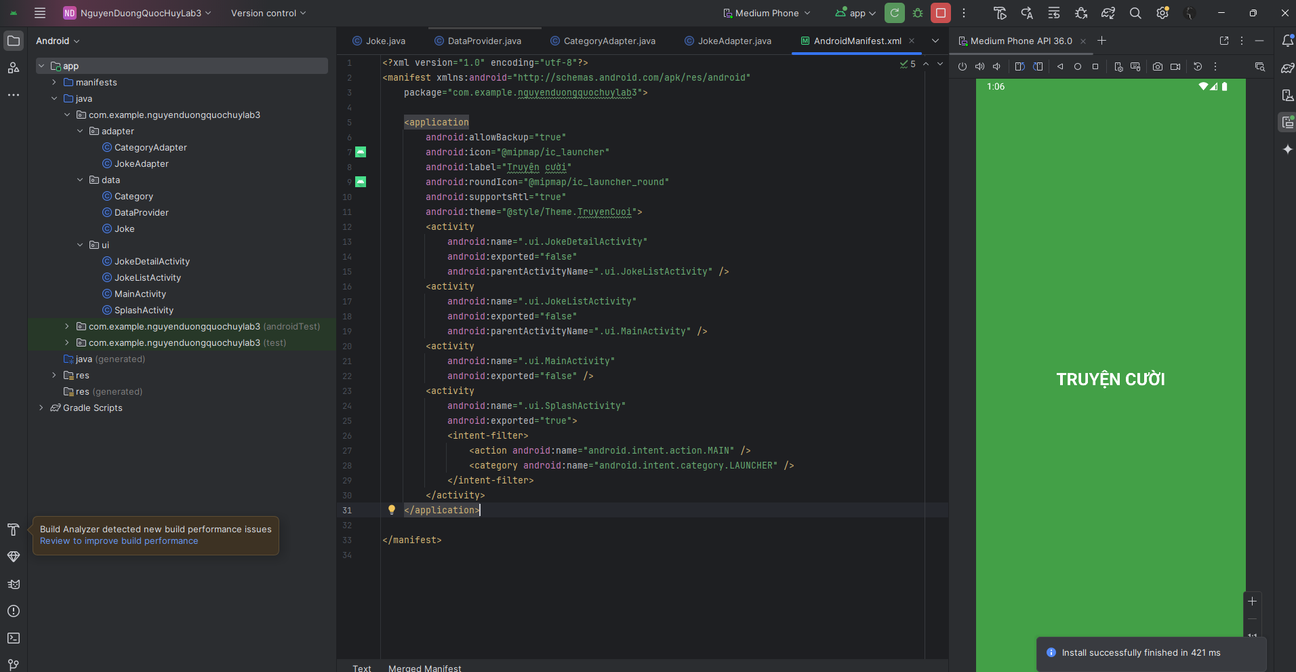

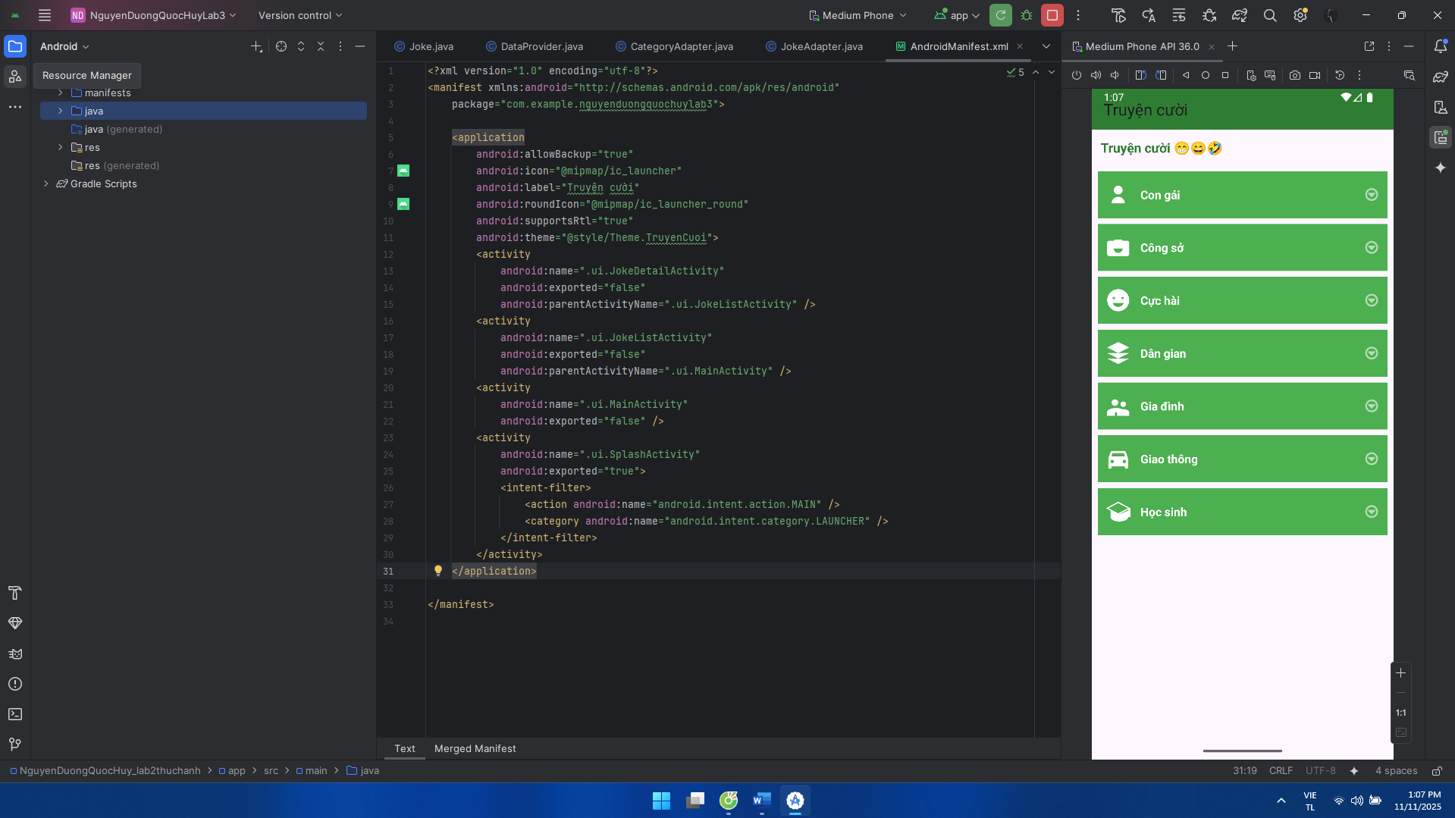

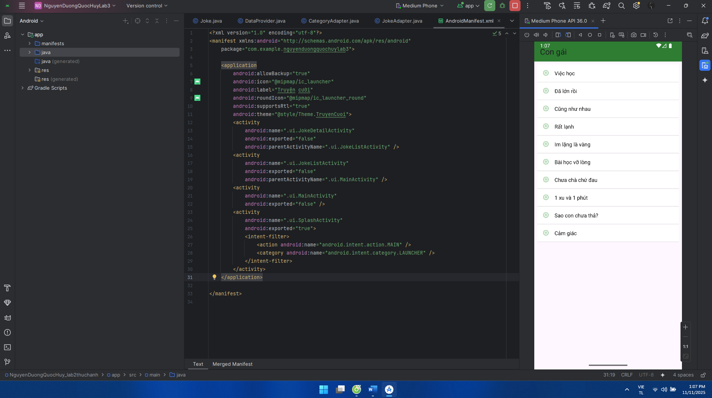

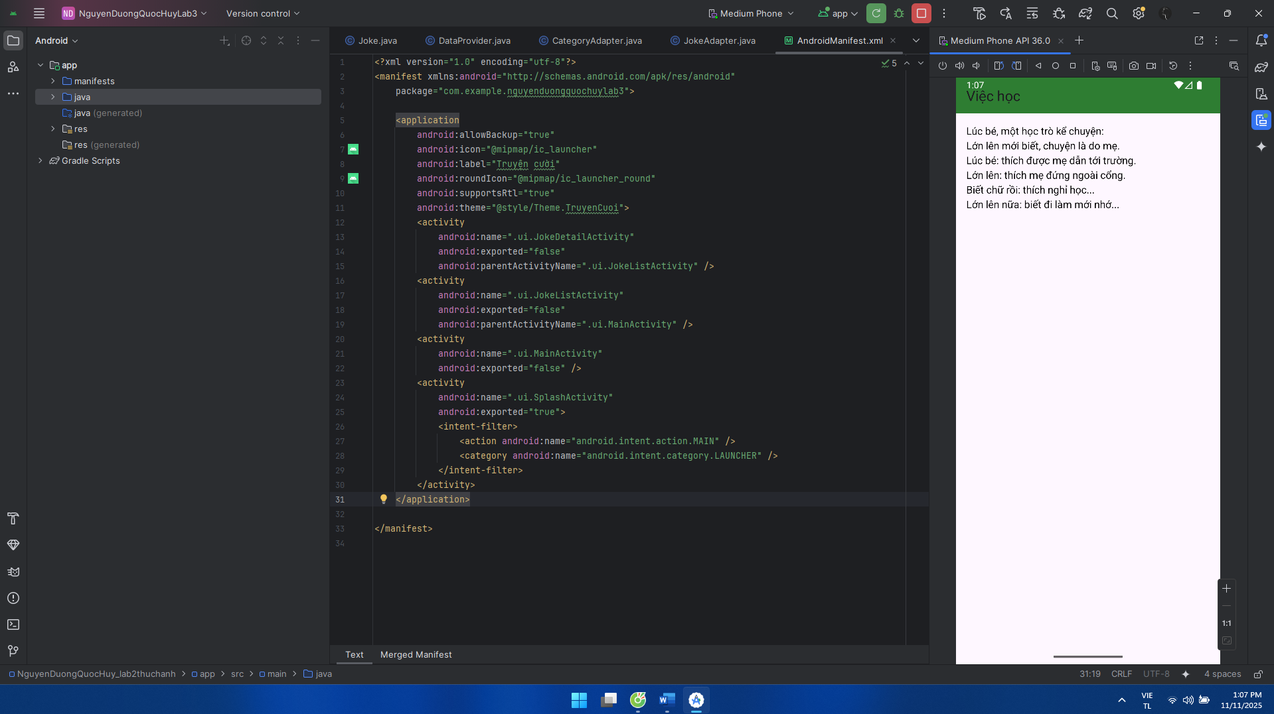

**Luyện tập 2: tạo giao diện chức nǎng theo ngôn ngữ máy:**

AndroidManifest:

<?xml version="1.0" encoding="utf-8"?>  
<manifest xmlns:android="http://schemas.android.com/apk/res/android"  
 package="com.example.nguyenduongquochuylab3">  
  
 <application  
 android:allowBackup="true"  
 android:icon="@mipmap/ic_launcher"  
 android:label="@string/app_name_en"  
 android:roundIcon="@mipmap/ic_launcher_round"  
 android:supportsRtl="true"  
 android:theme="@style/Theme.Animal">  
 <activity  
 android:name=".MainActivity"  
 android:exported="true">  
 <intent-filter>  
 <action android:name="android.intent.action.MAIN"/>  
 <category android:name="android.intent.category.LAUNCHER"/>  
 </intent-filter>  
 </activity>  
 </application>  
</manifest>

MainActivity:

package com.example.nguyenduongquochuylab3;  
  
import android.content.SharedPreferences;  
import android.os.Bundle;  
import android.widget.ImageButton;  
import android.widget.ImageView;  
import android.widget.TextView;  
  
import androidx.appcompat.app.AppCompatActivity;  
import androidx.appcompat.widget.Toolbar;  
  
import java.util.Locale;  
  
public class MainActivity extends AppCompatActivity {  
  
 private static final String *PREFS* = "app_prefs";  
 private static final String *KEY_LANG* = "pref_lang"; // "vi" hoặc "en"  
  
 private boolean favored = false;  
 private boolean isVi = false;  
  
 private Toolbar tb;  
 private TextView tvChip, tvDesc, btnLang;  
 private ImageButton btnFav;  
 private ImageView img;  
  
 @Override  
 protected void onCreate(Bundle savedInstanceState) {  
 super.onCreate(savedInstanceState);  
 setContentView(R.layout.*activity_main*);  
  
 tb = findViewById(R.id.*toolbar*);  
 setSupportActionBar(tb);  
  
 tvChip = findViewById(R.id.*tvChip*);  
 tvDesc = findViewById(R.id.*tvDesc*);  
 btnLang = findViewById(R.id.*btnLang*);  
 btnFav = findViewById(R.id.*btnFav*);  
 img = findViewById(R.id.*imgAnimal*);  
  
 int rabbitId = getResources().getIdentifier("rabbit", "drawable", getPackageName());  
 if (rabbitId == 0) img.setImageResource(R.mipmap.*ic_launcher*);  
  
 SharedPreferences sp = getSharedPreferences(*PREFS*, *MODE_PRIVATE*);  
 String savedLang = sp.getString(*KEY_LANG*, null);  
 if (savedLang == null) {  
 savedLang = Locale.*getDefault*().getLanguage().equalsIgnoreCase("vi") ? "vi" : "en";  
 sp.edit().putString(*KEY_LANG*, savedLang).apply();  
 }  
 isVi = savedLang.equals("vi");  
  
 renderUi();  
  
 btnLang.setOnClickListener(v -> {  
 isVi = !isVi;  
 sp.edit().putString(*KEY_LANG*, isVi ? "vi" : "en").apply();  
 renderUi();  
 });  
  
 btnFav.setOnClickListener(v -> {  
 favored = !favored;  
 btnFav.setImageResource(favored ? R.drawable.*ic_heart_filled* : R.drawable.*ic_heart*);  
 btnFav.setContentDescription(getString(  
 favored ? (isVi ? R.string.*unfav_vi* : R.string.*unfav_en*)  
 : (isVi ? R.string.*fav_vi* : R.string.*fav_en*)  
 ));  
 });  
 }  
  
 private void renderUi() {  
 btnLang.setText(isVi ? "EN" : "VI");  
  
 String title = getString(isVi ? R.string.*toolbar_title_vi* : R.string.*toolbar_title_en*);  
 String chip = getString(isVi ? R.string.*chip_title_vi* : R.string.*chip_title_en*);  
 String desc = getString(isVi ? R.string.*desc_text_vi* : R.string.*desc_text_en*);  
  
 tb.setTitle(title);  
 tvChip.setText(chip);  
 tvDesc.setText(desc);  
  
 btnFav.setContentDescription(getString(  
 favored ? (isVi ? R.string.*unfav_vi* : R.string.*unfav_en*)  
 : (isVi ? R.string.*fav_vi* : R.string.*fav_en*)  
 ));  
 }  
}

bg_chip:

<?xml version="1.0" encoding="utf-8"?>  
<shape xmlns:android="http://schemas.android.com/apk/res/android">  
 <solid android:color="@color/chip_bg"/>  
 <corners android:radius="20dp"/>  
 <padding android:left="12dp" android:top="6dp" android:right="12dp" android:bottom="6dp"/>  
</shape>

ic_heart:

<?xml version="1.0" encoding="utf-8"?>  
<shape xmlns:android="http://schemas.android.com/apk/res/android">  
 <solid android:color="@color/chip_bg"/>  
 <corners android:radius="20dp"/>  
 <padding android:left="12dp" android:top="6dp" android:right="12dp" android:bottom="6dp"/>  
</shape>

ic_heart_filled:

<vector xmlns:android="http://schemas.android.com/apk/res/android"  
 android:width="24dp" android:height="24dp" android:viewportWidth="24" android:viewportHeight="24">  
 <path android:fillColor="@color/white"  
 android:pathData="M12,21L10.55,19.65C5.4,15 2,12 2,8.5C2,6 4,4 6.5,4C8.04,4 9.54,4.81 10.35,6.08C11.16,4.81 12.66,4 14.2,4C16.7,4 18.7,6 18.7,8.5C18.7,12 15.3,15 10.15,19.65L12,21Z"/>  
</vector>

Rabbit.jpg:



activity_main:

<?xml version="1.0" encoding="utf-8"?>  
<LinearLayout xmlns:android="http://schemas.android.com/apk/res/android"  
 android:layout_width="match_parent" android:layout_height="match_parent"  
 android:orientation="vertical">  
  
 <androidx.appcompat.widget.Toolbar  
 android:id="@+id/toolbar"  
 android:layout_width="match_parent" android:layout_height="56dp"  
 android:background="@color/purple_700"  
 android:titleTextColor="@color/white" />  
  
 <ScrollView  
 android:layout_width="match_parent" android:layout_height="match_parent">  
  
 <LinearLayout  
 android:layout_width="match_parent" android:layout_height="wrap_content"  
 android:orientation="vertical" android:padding="12dp">  
  
 <!-- Hàng chip + nút VI/EN + tim -->  
 <LinearLayout  
 android:layout_width="match_parent" android:layout_height="wrap_content"  
 android:orientation="horizontal" android:gravity="center_vertical">  
  
 <TextView  
 android:id="@+id/tvChip"  
 android:layout_width="wrap_content" android:layout_height="wrap_content"  
 android:background="@drawable/bg_chip"  
 android:text="Rabbit"  
 android:textColor="@color/white" android:textStyle="bold"  
 android:textSize="18sp"/>  
  
 <Space  
 android:layout_width="0dp" android:layout_height="1dp"  
 android:layout_weight="1"/>  
  
 <TextView  
 android:id="@+id/btnLang"  
 android:layout_width="wrap_content" android:layout_height="wrap_content"  
 android:background="@drawable/bg_chip"  
 android:text="VI"  
 android:textColor="@color/white" android:textStyle="bold"  
 android:paddingLeft="12dp" android:paddingRight="12dp"  
 android:layout_marginEnd="8dp" />  
  
 <ImageButton  
 android:id="@+id/btnFav"  
 android:layout_width="40dp" android:layout_height="40dp"  
 android:background="@android:color/transparent"  
 android:contentDescription="Favorite"  
 android:src="@drawable/ic_heart"/>  
 </LinearLayout>  
  
 <TextView  
 android:id="@+id/tvDesc"  
 android:layout_width="match_parent" android:layout_height="wrap_content"  
 android:textColor="@color/black" android:textSize="15sp"  
 android:lineSpacingExtra="3dp" android:layout_marginTop="8dp"  
 android:text="..."/>  
  
 <ImageView  
 android:id="@+id/imgAnimal"  
 android:layout_width="match_parent" android:layout_height="220dp"  
 android:scaleType="centerCrop" android:layout_marginTop="10dp"  
 android:src="@drawable/rabbit"/>  
 </LinearLayout>  
 </ScrollView>  
</LinearLayout>

Themes:

<?xml version="1.0" encoding="utf-8"?>  
<resources>  
 <style name="Theme.Animal" parent="Theme.Material3.Light.NoActionBar">  
 <item name="colorPrimary">@color/purple_600</item>  
 <item name="colorPrimaryContainer">@color/purple_700</item>  
 <item name="android:statusBarColor">@color/purple_700</item>  
 </style>  
</resources>

Colors:

<?xml version="1.0" encoding="utf-8"?>  
<resources>  
 <color name="purple_700">#512DA8</color>  
 <color name="purple_600">#5E35B1</color>  
 <color name="white">#FFFFFF</color>  
 <color name="black">#000000</color>  
 <color name="chip_bg">#5E35B1</color>  
</resources>

Strings:

<resources>  
 <string name="app_name_en">Animal</string>  
 <string name="toolbar_title_en">Animal</string>  
 <string name="chip_title_en">Rabbit</string>  
 <string name="desc_text_en">Rabbits are small mammals in the family Leporidae (along with the hare) of the order Lagomorpha (along with the pika). Oryctolagus cuniculus includes the European rabbit species and its descendants, the world’s 305 breeds of domestic rabbit. Sylvilagus includes 13 wild rabbit species, among them the seven types of cottontail. The European rabbit, which has been introduced on every continent except Antarctica, is familiar throughout the world as a wild prey animal and as a domesticated companion.</string>  
 <string name="fav_en">Favorite</string>  
 <string name="unfav_en">Unfavorite</string>  
 <string name="img_desc_en">Rabbit image</string>  
  
 <string name="app_name_vi">Âm thanh động vật</string>  
 <string name="toolbar_title_vi">Âm thanh động vật</string>  
 <string name="chip_title_vi">Thỏ</string>  
 <string name="desc_text_vi">Thỏ là loài động vật có vú nhỏ thuộc họ Leporidae (cùng với thỏ rừng) trong bộ Lagomorpha (cùng với pika). Oryctolagus cuniculus bao gồm loài thỏ châu Âu và con cháu của nó, 305 giống thỏ nhà trên thế giới. Sylvilagus bao gồm 13 loài thỏ hoang dã, trong đó có bảy loại thỏ bông đuôi cộc. Thỏ châu Âu, được du nhập tới mọi lục địa ngoại trừ Nam Cực, là động vật quen thuộc khắp thế giới vừa là mồi tự nhiên vừa là vật nuôi đã thuần hoá.</string>  
 <string name="fav_vi">Yêu thích</string>  
 <string name="unfav_vi">Bỏ yêu thích</string>  
 <string name="img_desc_vi">Hình con thỏ</string>  
</resources>

Giao diện:

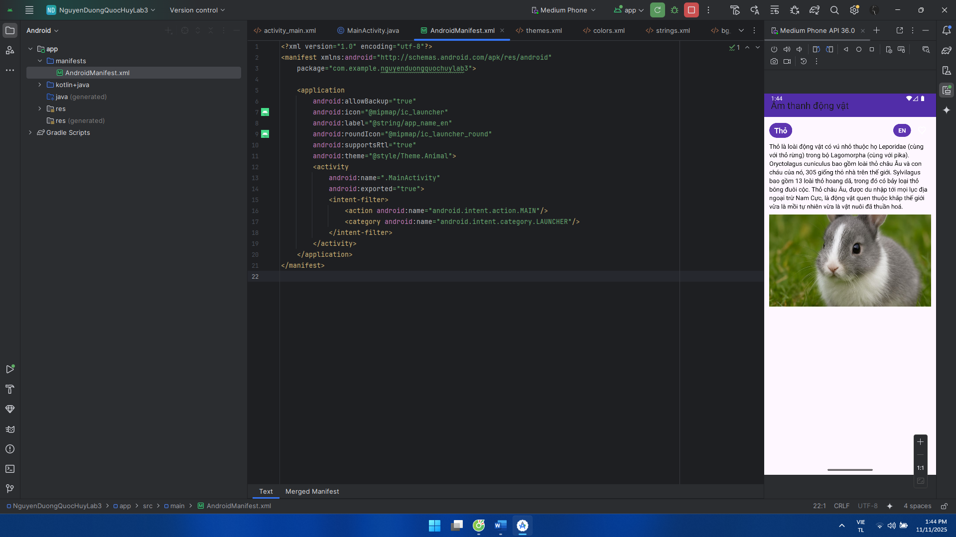

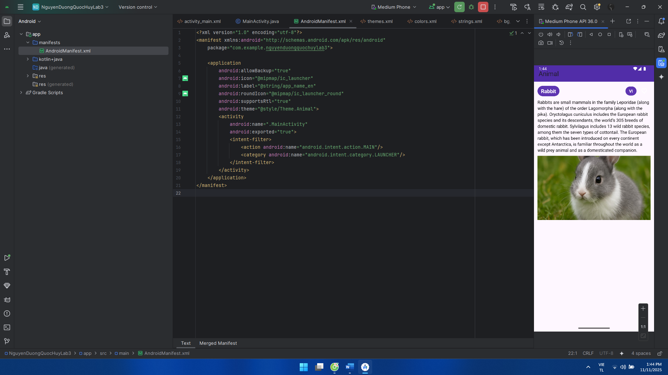

**Bài tập 1:**

Từ luyện tập 1 dùng code của truyện cười và thêm

AndroidManifest:

<activity  
 android:name=".ui.SplashActivity"  
 android:exported="true">  
 <intent-filter>  
 <action android:name="android.intent.action.MAIN" />  
 <category android:name="android.intent.category.LAUNCHER" />

OrientationHelper:

package com.example.nguyenduongquochuylab3.util;  
  
import android.app.Activity;  
import android.content.Context;  
import android.content.SharedPreferences;  
import android.content.pm.ActivityInfo;  
  
public class OrientationHelper {  
 private static final String *PREF* = "rotate_pref";  
 private static final String *KEY_ALLOW* = "allow_rotate";  
  
 public static boolean isAllowed(Context ctx) {  
 return ctx.getSharedPreferences(*PREF*, Context.*MODE_PRIVATE*).getBoolean(*KEY_ALLOW*, true);  
 }  
  
 public static void setAllowed(Context ctx, boolean allow) {  
 SharedPreferences sp = ctx.getSharedPreferences(*PREF*, Context.*MODE_PRIVATE*);  
 sp.edit().putBoolean(*KEY_ALLOW*, allow).apply();  
 }  
  
 public static void apply(Activity act) {  
 if (*isAllowed*(act)) {  
 act.setRequestedOrientation(ActivityInfo.*SCREEN_ORIENTATION_UNSPECIFIED*);  
 } else {  
 act.setRequestedOrientation(ActivityInfo.*SCREEN_ORIENTATION_PORTRAIT*);  
 }  
 }  
}

OrientationActivity:

package com.example.nguyenduongquochuylab3.ui;  
  
import android.os.Bundle;  
import androidx.appcompat.app.AppCompatActivity;  
import androidx.appcompat.widget.SwitchCompat;  
import androidx.appcompat.widget.Toolbar;  
import com.example.nguyenduongquochuylab3.R;  
import com.example.nguyenduongquochuylab3.util.OrientationHelper;  
  
public class OrientationActivity extends AppCompatActivity {  
  
 @Override protected void onCreate(Bundle savedInstanceState) {  
 super.onCreate(savedInstanceState);  
 setContentView(R.layout.*activity_orientation*);  
 OrientationHelper.*apply*(this);  
  
 Toolbar tb = findViewById(R.id.*toolbar*);  
 tb.setTitle("Bật/Tắt xoay màn hình");  
 setSupportActionBar(tb);  
 tb.setNavigationOnClickListener(v -> onBackPressed());  
  
 SwitchCompat sw = findViewById(R.id.*swRotate*);  
 sw.setChecked(OrientationHelper.*isAllowed*(this));  
 sw.setOnCheckedChangeListener((buttonView, isChecked) -> {  
 OrientationHelper.*setAllowed*(OrientationActivity.this, isChecked);  
 OrientationHelper.*apply*(OrientationActivity.this);  
 });  
 }  
}

activity_orientation:

<?xml version="1.0" encoding="utf-8"?>

<LinearLayout xmlns:android="http://schemas.android.com/apk/res/android"

android:layout_width="match_parent" android:layout_height="match_parent"

android:orientation="vertical">

<include layout="@layout/include_toolbar"/>

<LinearLayout

android:layout_width="match_parent" android:layout_height="wrap_content"

android:orientation="horizontal" android:padding="16dp"

android:gravity="center_vertical">

<TextView

android:layout_width="0dp" android:layout_height="wrap_content"

android:layout_weight="1"

android:text="Cho phép xoay ngang màn hình"

android:textSize="16sp"/>

<androidx.appcompat.widget.SwitchCompat

android:id="@+id/swRotate"

android:layout_width="wrap_content" android:layout_height="wrap_content"/>

</LinearLayout>

</LinearLayout>

Ở SplashActivity, MainActivity, JokeListActivity, JokeDetailActivity thêm:

setContentView(R.layout.tên của layout đó); vào @Override protected void onCreate(Bundle savedInstanceState)

Giao diện:

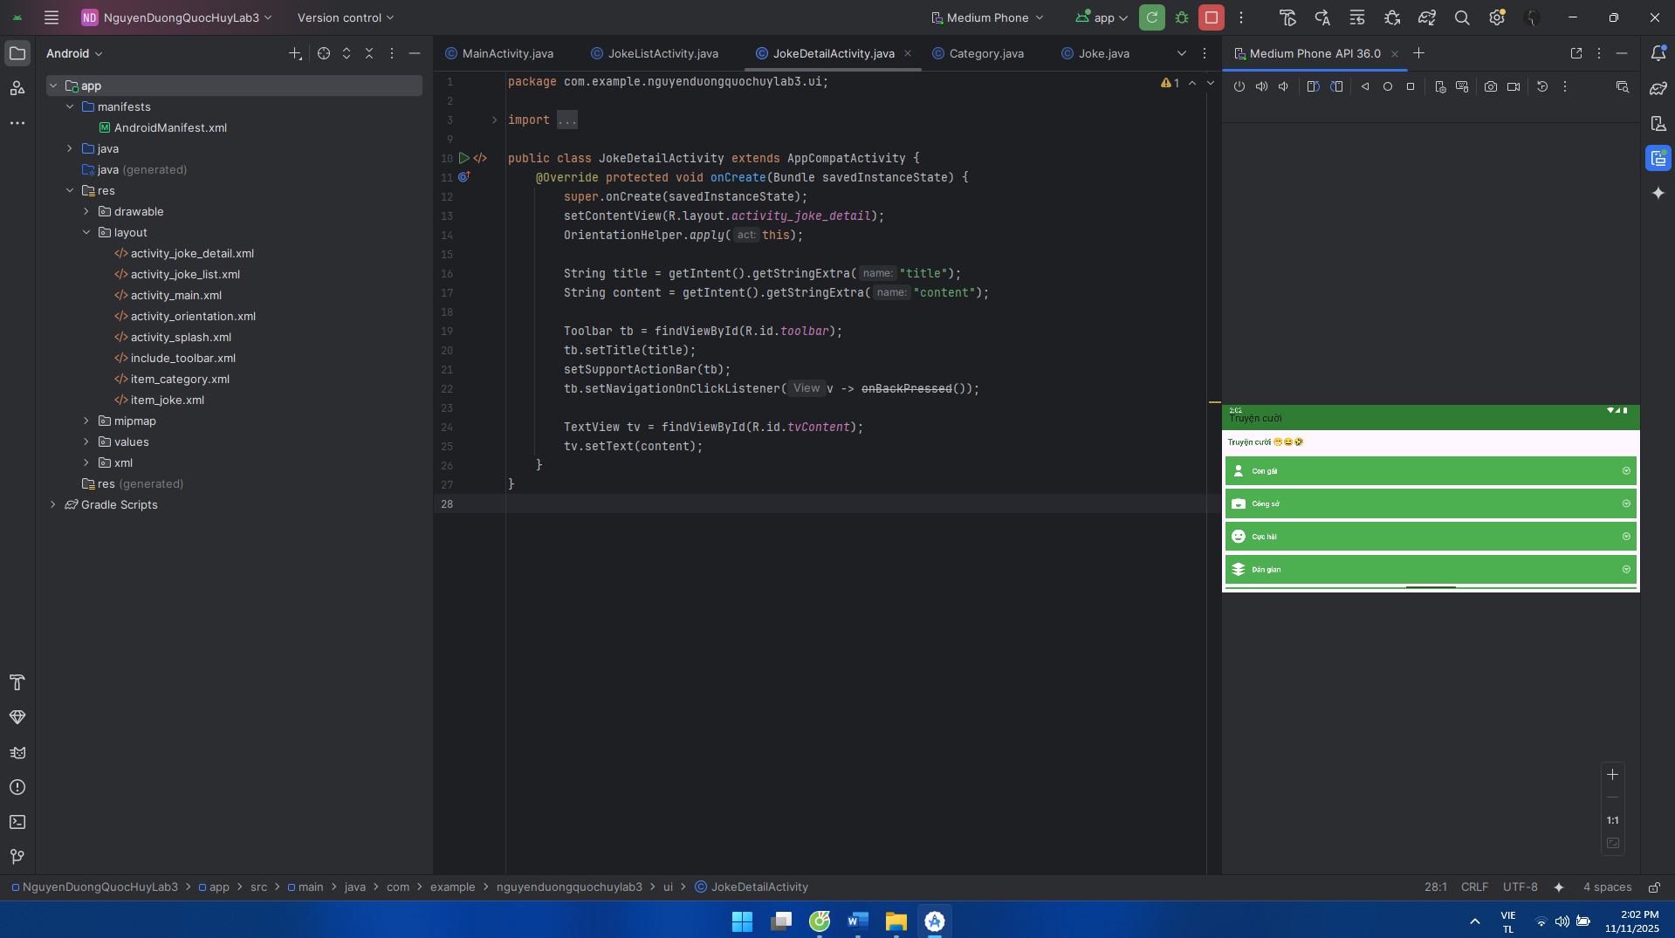

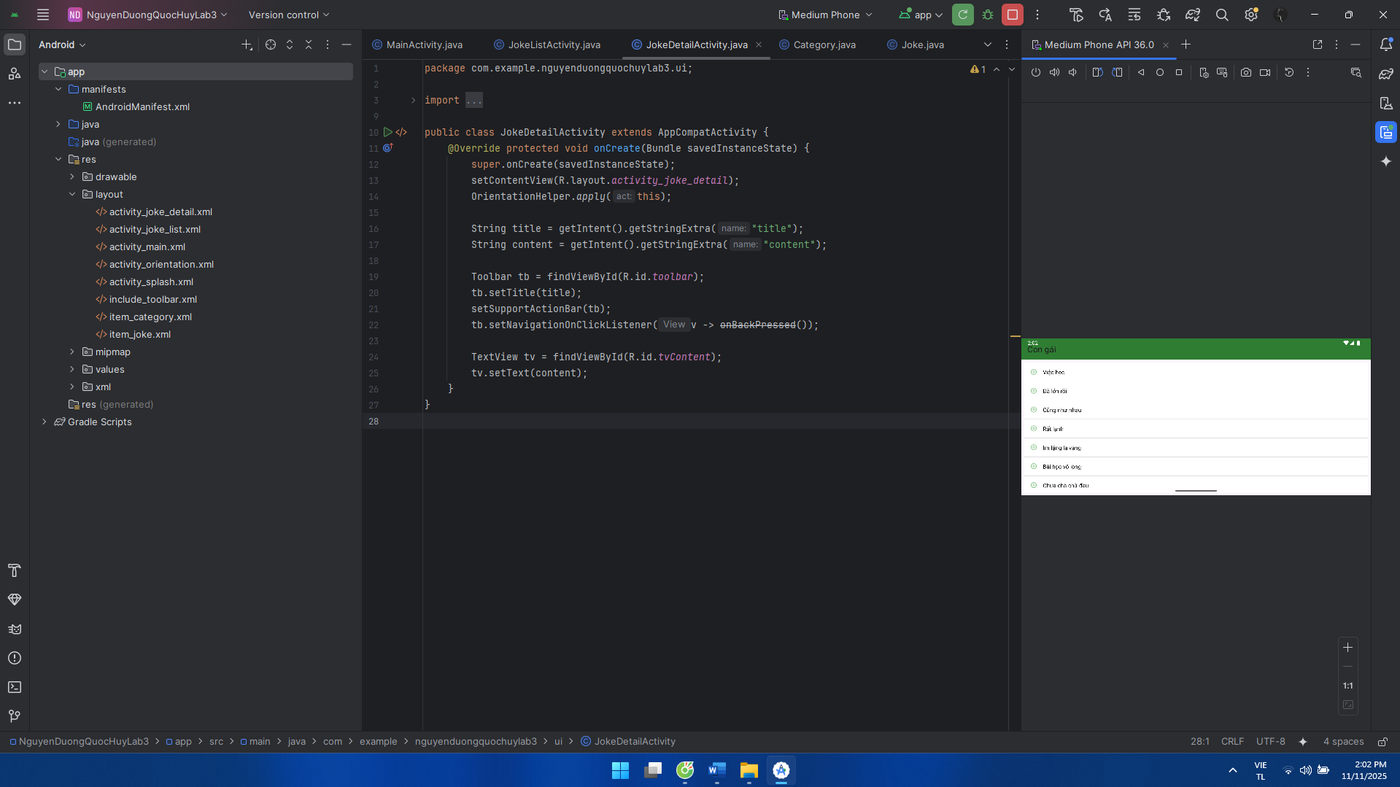

**Bài tập 2:**Từ luyện tập 2 bắt đầu làm thêm

AndroidManifest:

<?xml version="1.0" encoding="utf-8"?>  
<manifest xmlns:android="http://schemas.android.com/apk/res/android"  
 package="com.example.nguyenduongquochuylab3">  
  
 <application  
 android:allowBackup="true"  
 android:icon="@mipmap/ic_launcher"  
 android:label="@string/app_name_en"  
 android:roundIcon="@mipmap/ic_launcher_round"  
 android:supportsRtl="true"  
 android:theme="@style/Theme.MultiLang">  
 <activity  
 android:name=".MainActivity"  
 android:exported="true">  
 <intent-filter>  
 <action android:name="android.intent.action.MAIN"/>  
 <category android:name="android.intent.category.LAUNCHER"/>  
 </intent-filter>  
 </activity>  
 </application>  
</manifest>

MainActivity:

package com.example.nguyenduongquochuylab3;  
  
import android.content.SharedPreferences;  
import android.os.Bundle;  
import android.view.Menu;  
import android.view.MenuItem;  
import android.widget.Button;  
import android.widget.EditText;  
import android.widget.TextView;  
  
import androidx.appcompat.app.AppCompatActivity;  
import androidx.appcompat.widget.Toolbar;  
  
import java.util.Locale;  
  
public class MainActivity extends AppCompatActivity {  
  
 private static final String *PREFS* = "ml_prefs";  
 private static final String *KEY_LANG* = "lang";  
  
 private Toolbar toolbar;  
 private TextView tvTitle, tvSignup, tvVi, tvEn, tvFr;  
 private EditText edtEmail, edtPassword;  
 private Button btnLogin;  
  
 private String lang = "en";  
  
 @Override  
 protected void onCreate(Bundle savedInstanceState) {  
 super.onCreate(savedInstanceState);  
 setContentView(R.layout.*activity_main*);  
  
 toolbar = findViewById(R.id.*toolbar*);  
 setSupportActionBar(toolbar);  
  
  
 tvTitle = findViewById(R.id.*tvTitle*);  
 edtEmail = findViewById(R.id.*edtEmail*);  
 edtPassword= findViewById(R.id.*edtPassword*);  
 btnLogin = findViewById(R.id.*btnLogin*);  
 tvSignup = findViewById(R.id.*tvSignup*);  
 tvVi = findViewById(R.id.*tvVi*);  
 tvEn = findViewById(R.id.*tvEn*);  
 tvFr = findViewById(R.id.*tvFr*);  
  
 SharedPreferences sp = getSharedPreferences(*PREFS*, *MODE_PRIVATE*);  
 lang = sp.getString(*KEY_LANG*, null);  
 if (lang == null) {  
 String sys = Locale.*getDefault*().getLanguage();  
 lang = sys.equalsIgnoreCase("vi") ? "vi" : (sys.equalsIgnoreCase("fr") ? "fr" : "en");  
 sp.edit().putString(*KEY_LANG*, lang).apply();  
 }  
 renderUi();  
  
 tvVi.setOnClickListener(v -> setLang("vi"));  
 tvEn.setOnClickListener(v -> setLang("en"));  
 tvFr.setOnClickListener(v -> setLang("fr"));  
 }  
  
 private void setLang(String l) {  
 lang = l;  
 getSharedPreferences(*PREFS*, *MODE_PRIVATE*).edit().putString(*KEY_LANG*, lang).apply();  
 renderUi();  
 }  
  
 private void renderUi() {  
 switch (lang) {  
 case "vi":  
 setTitle(getString(R.string.*app_name_vi*));  
 toolbar.setTitle(getString(R.string.*app_name_vi*));  
 tvTitle.setText(getString(R.string.*title_vi*));  
 edtEmail.setHint(getString(R.string.*email_vi*));  
 edtPassword.setHint(getString(R.string.*password_vi*));  
 btnLogin.setText(getString(R.string.*login_vi*));  
 tvSignup.setText(getString(R.string.*no_account_vi*));  
 tvVi.setText(getString(R.string.*vi_vi*));  
 tvEn.setText(getString(R.string.*en_vi*));  
 tvFr.setText(getString(R.string.*fr_vi*));  
 break;  
 case "fr":  
 setTitle(getString(R.string.*app_name_fr*));  
 toolbar.setTitle(getString(R.string.*app_name_fr*));  
 tvTitle.setText(getString(R.string.*title_fr*));  
 edtEmail.setHint(getString(R.string.*email_fr*));  
 edtPassword.setHint(getString(R.string.*password_fr*));  
 btnLogin.setText(getString(R.string.*login_fr*));  
 tvSignup.setText(getString(R.string.*no_account_fr*));  
 tvVi.setText(getString(R.string.*vi_fr*));  
 tvEn.setText(getString(R.string.*en_fr*));  
 tvFr.setText(getString(R.string.*fr_fr*));  
 break;  
 default:  
 setTitle(getString(R.string.*app_name_en*));  
 toolbar.setTitle(getString(R.string.*app_name_en*));  
 tvTitle.setText(getString(R.string.*title_en*));  
 edtEmail.setHint(getString(R.string.*email_en*));  
 edtPassword.setHint(getString(R.string.*password_en*));  
 btnLogin.setText(getString(R.string.*login_en*));  
 tvSignup.setText(getString(R.string.*no_account_en*));  
 tvVi.setText(getString(R.string.*vi_en*));  
 tvEn.setText(getString(R.string.*en_en*));  
 tvFr.setText(getString(R.string.*fr_en*));  
 }  
 }  
  
 @Override  
 public boolean onCreateOptionsMenu(Menu menu) {  
 getMenuInflater().inflate(R.menu.*menu_lang*, menu);  
 return true;  
 }  
 @Override  
 public boolean onOptionsItemSelected(MenuItem item) {  
 int id = item.getItemId();  
 if (id == R.id.*mnu_vi*) { setLang("vi"); return true; }  
 if (id == R.id.*mnu_en*) { setLang("en"); return true; }  
 if (id == R.id.*mnu_fr*) { setLang("fr"); return true; }  
 return super.onOptionsItemSelected(item);  
 }  
}

activity_main:

<?xml version="1.0" encoding="utf-8"?>  
<LinearLayout xmlns:android="http://schemas.android.com/apk/res/android"  
 android:layout_width="match_parent" android:layout_height="match_parent"  
 android:orientation="vertical">  
  
 <androidx.appcompat.widget.Toolbar  
 android:id="@+id/toolbar"  
 android:layout_width="match_parent" android:layout_height="56dp"  
 android:background="@color/primary_700"  
 android:titleTextColor="@color/white" />  
  
 <ScrollView  
 android:layout_width="match_parent" android:layout_height="match_parent">  
  
 <LinearLayout  
 android:layout_width="match_parent" android:layout_height="wrap_content"  
 android:orientation="vertical" android:padding="24dp">  
 <TextView  
 android:id="@+id/tvTitle"  
 android:layout_width="match_parent" android:layout_height="wrap_content"  
 android:textSize="28sp" android:textStyle="bold"  
 android:textColor="@color/white"  
 android:padding="12dp"  
 android:background="@color/primary_600"  
 android:text="Welcome!"/>  
 <EditText  
 android:id="@+id/edtEmail"  
 android:layout_width="match_parent" android:layout_height="wrap_content"  
 android:layout_marginTop="24dp"  
 android:hint="Email Address"  
 android:inputType="textEmailAddress"  
 android:padding="12dp"/>  
 <EditText  
 android:id="@+id/edtPassword"  
 android:layout_width="match_parent" android:layout_height="wrap_content"  
 android:layout_marginTop="12dp"  
 android:hint="Password"  
 android:inputType="textPassword"  
 android:padding="12dp"/>  
 <Button  
 android:id="@+id/btnLogin"  
 android:layout_width="match_parent" android:layout_height="wrap_content"  
 android:layout_marginTop="16dp"  
 android:text="LOGIN"/>  
 <TextView  
 android:id="@+id/tvSignup"  
 android:layout_width="match_parent" android:layout_height="wrap_content"  
 android:layout_marginTop="12dp"  
 android:text="Don’t have an account? Sign Up"  
 android:textColor="@color/link"/>  
 <LinearLayout  
 android:layout_width="match_parent" android:layout_height="wrap_content"  
 android:layout_marginTop="24dp"  
 android:gravity="center_horizontal"  
 android:orientation="horizontal">  
  
 <TextView  
 android:id="@+id/tvVi"  
 android:layout_width="wrap_content" android:layout_height="wrap_content"  
 android:text="Tiếng Việt" android:textColor="@color/link" android:padding="8dp"/>  
 <TextView android:layout_width="wrap_content" android:layout_height="wrap_content" android:text=" | "/>  
 <TextView  
 android:id="@+id/tvEn"  
 android:layout_width="wrap_content" android:layout_height="wrap_content"  
 android:text="English" android:textColor="@color/link" android:padding="8dp"/>  
 <TextView android:layout_width="wrap_content" android:layout_height="wrap_content" android:text=" | "/>  
 <TextView  
 android:id="@+id/tvFr"  
 android:layout_width="wrap_content" android:layout_height="wrap_content"  
 android:text="Français" android:textColor="@color/link" android:padding="8dp"/>  
 </LinearLayout>  
  
 </LinearLayout>  
 </ScrollView>  
</LinearLayout>

Strings:

<resources>  
 <string name="app_name_en">Multi Language App</string>  
 <string name="title_en">Welcome!</string>  
 <string name="email_en">Email Address</string>  
 <string name="password_en">Password</string>  
 <string name="login_en">LOGIN</string>  
 <string name="no_account_en">Don’t have an account? Sign Up</string>  
 <string name="vi_en">Tiếng Việt</string>  
 <string name="en_en">English</string>  
 <string name="fr_en">Français</string>  
  
 <string name="app_name_vi">Ứng dụng đa ngôn ngữ</string>  
 <string name="title_vi">Xin chào</string>  
 <string name="email_vi">Email</string>  
 <string name="password_vi">Mật khẩu</string>  
 <string name="login_vi">ĐĂNG NHẬP</string>  
 <string name="no_account_vi">Không có tài khoản. Vui lòng đăng ký</string>  
 <string name="vi_vi">Tiếng Việt</string>  
 <string name="en_vi">English</string>  
 <string name="fr_vi">Français</string>  
  
 <string name="app_name_fr">Application multilingue</string>  
 <string name="title_fr">accueil</string>  
 <string name="email_fr">adresse e-mail</string>  
 <string name="password_fr">mot de passe</string>  
 <string name="login_fr">CONNEXION</string>  
 <string name="no_account_fr">Ne pas avoir un compte? signer</string>  
 <string name="vi_fr">Tiếng Việt</string>  
 <string name="en_fr">English</string>  
 <string name="fr_fr">Français</string>  
  
 <string name="menu_language">Language</string>  
 <string name="menu_vi">Tiếng Việt</string>  
 <string name="menu_en">English</string>  
 <string name="menu_fr">Français</string>  
</resources>

Giao diện: 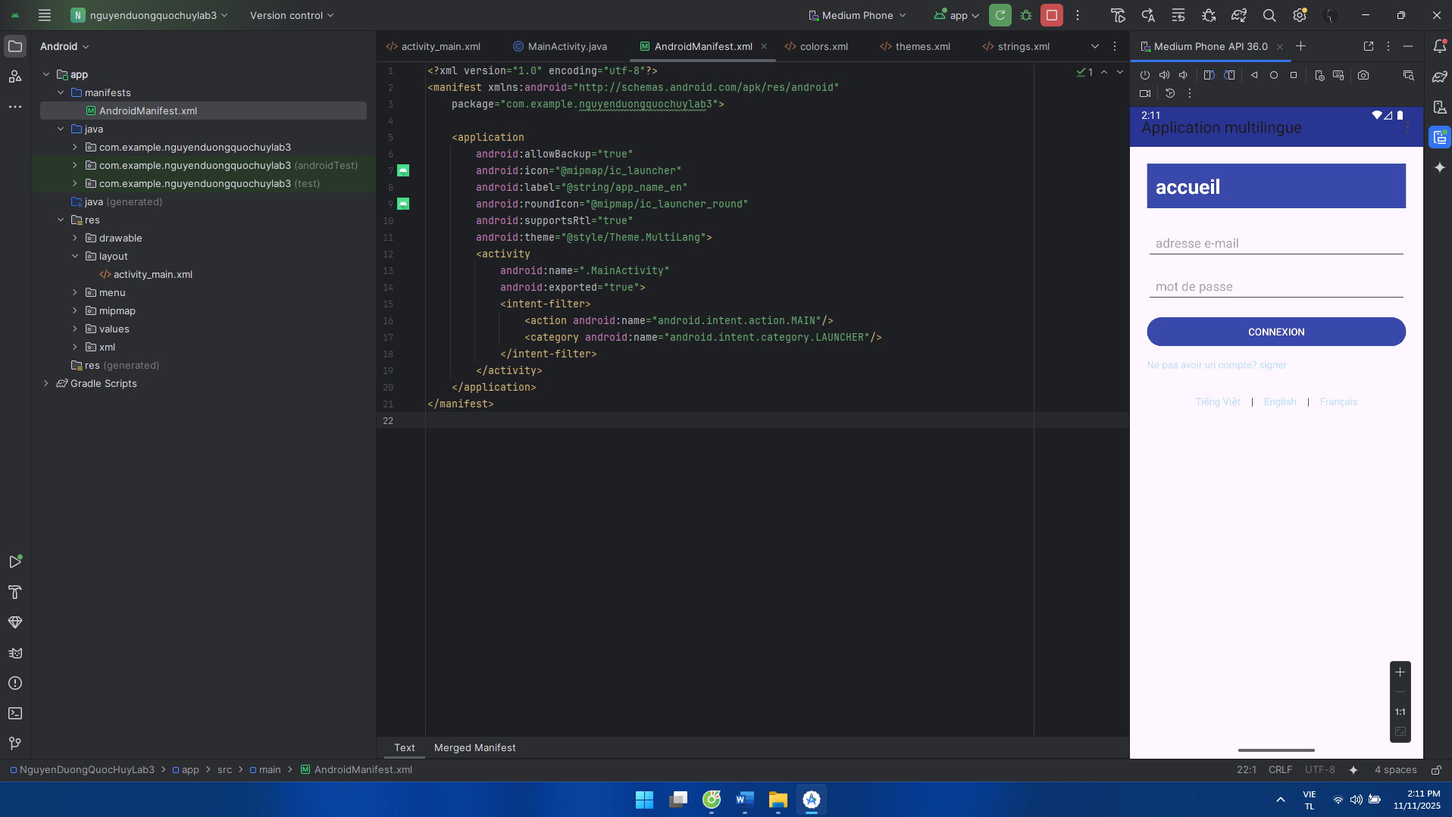

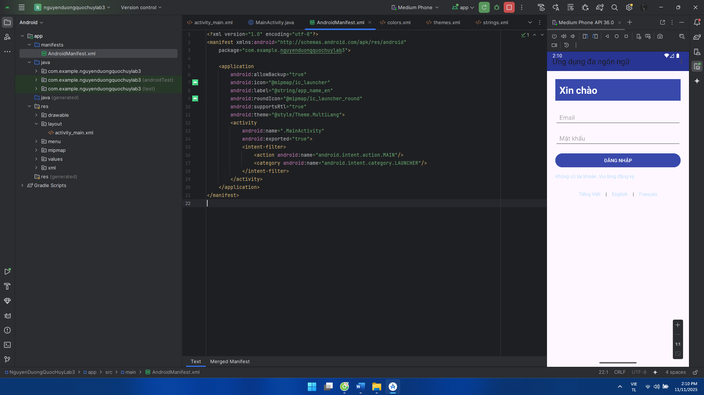

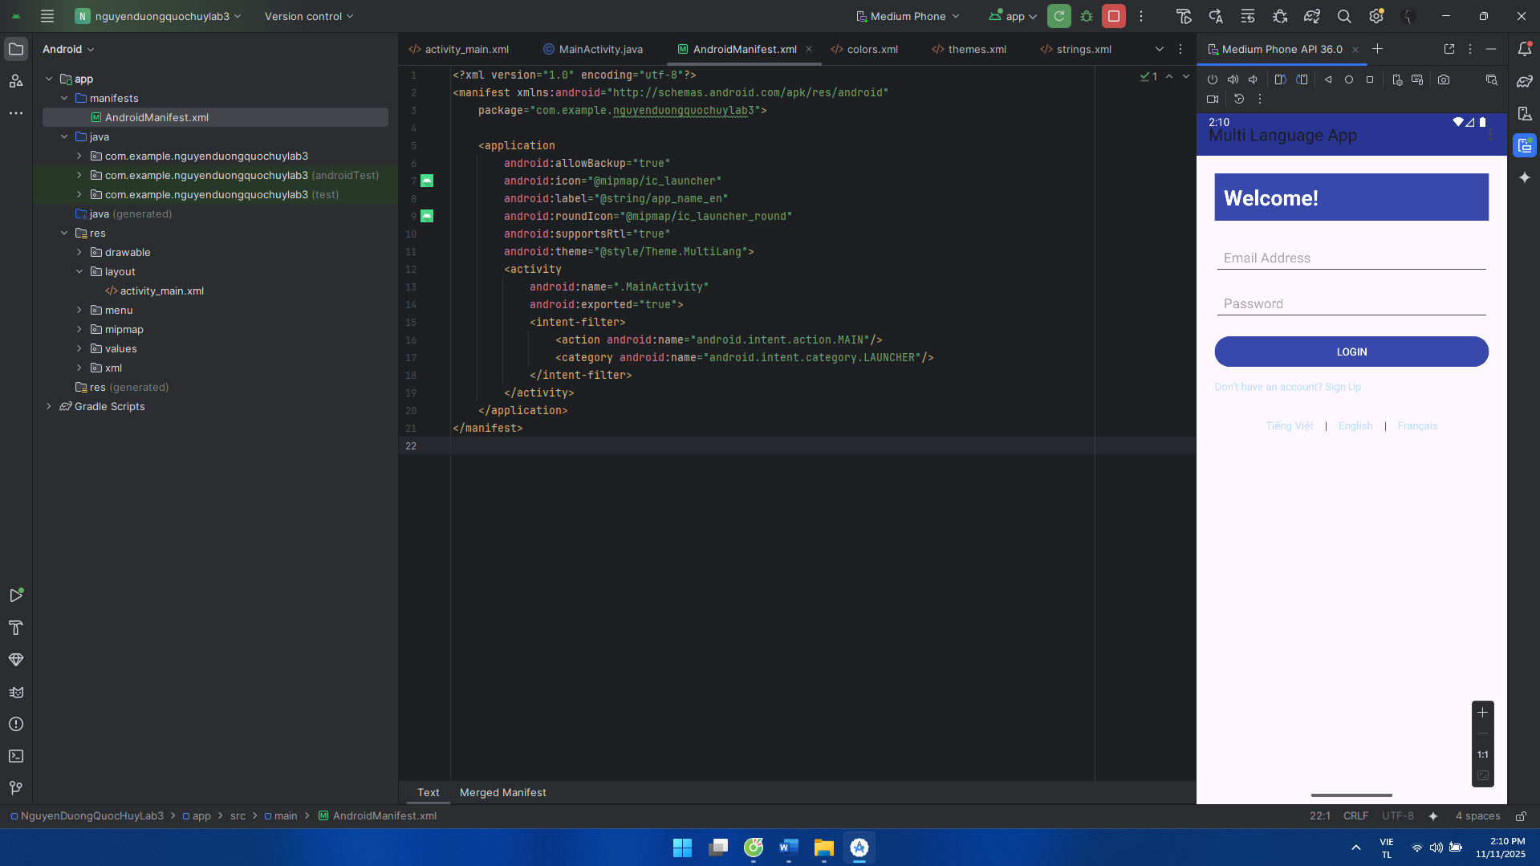

**LAB 4**

**Luyện tập 1: tạo giao diện login:**

AndroidManifest:

<?xml version="1.0" encoding="utf-8"?>  
<manifest xmlns:android="http://schemas.android.com/apk/res/android"  
 package="com.example.nguyenduongquochuylab3">  
  
 <application  
 android:allowBackup="true"  
 android:icon="@mipmap/ic_launcher"  
 android:label="@string/app_name"  
 android:roundIcon="@mipmap/ic_launcher_round"  
 android:supportsRtl="true"  
 android:theme="@style/Theme.App">  
 <activity  
 android:name=".MainActivity"  
 android:exported="true">  
 <intent-filter>  
 <action android:name="android.intent.action.MAIN"/>  
 <category android:name="android.intent.category.LAUNCHER"/>  
 </intent-filter>  
 </activity>  
 </application>  
</manifest>

MainActivity:

package com.example.nguyenduongquochuylab3;  
  
import android.os.Bundle;  
import android.widget.Button;  
import android.widget.EditText;  
import android.widget.TextView;  
import android.widget.Toast;  
  
import androidx.appcompat.app.AppCompatActivity;  
  
public class MainActivity extends AppCompatActivity {  
  
 EditText edtEmail, edtPassword;  
 Button btnLogin;  
 TextView tvForgot, tvRegister;  
  
 @Override  
 protected void onCreate(Bundle savedInstanceState) {  
 super.onCreate(savedInstanceState);  
 setContentView(R.layout.*activity_main*);  
  
 edtEmail = findViewById(R.id.*edtEmail*);  
 edtPassword = findViewById(R.id.*edtPassword*);  
 btnLogin = findViewById(R.id.*btnLogin*);  
 tvForgot = findViewById(R.id.*tvForgot*);  
 tvRegister = findViewById(R.id.*tvRegister*);  
  
 btnLogin.setOnClickListener(v ->  
 Toast.*makeText*(this, "Login clicked", Toast.*LENGTH_SHORT*).show()  
 );  
 tvForgot.setOnClickListener(v ->  
 Toast.*makeText*(this, "Forgot password?", Toast.*LENGTH_SHORT*).show()  
 );  
 tvRegister.setOnClickListener(v ->  
 Toast.*makeText*(this, "Go to Register", Toast.*LENGTH_SHORT*).show()  
 );  
 }  
}

bg_btn_login:

<?xml version="1.0" encoding="utf-8"?>  
<shape xmlns:android="http://schemas.android.com/apk/res/android">  
 <gradient android:startColor="@color/orange_start" android:endColor="@color/orange_end" android:angle="0"/>  
 <corners android:radius="22dp"/>  
 <padding android:left="16dp" android:top="12dp" android:right="16dp" android:bottom="12dp"/>  
</shape>

bg_header:

<?xml version="1.0" encoding="utf-8"?>  
<shape xmlns:android="http://schemas.android.com/apk/res/android" android:shape="rectangle">  
 <gradient android:startColor="@color/orange_start" android:endColor="@color/orange_end"  
 android:angle="270"/>  
 <corners android:bottomLeftRadius="56dp"/>  
</shape>

bg_input:

<?xml version="1.0" encoding="utf-8"?>  
<shape xmlns:android="http://schemas.android.com/apk/res/android">  
 <solid android:color="@color/white"/>  
 <corners android:radius="22dp"/>  
 <padding android:left="12dp" android:top="10dp" android:right="12dp" android:bottom="10dp"/>  
</shape>

ic_email:

<vector xmlns:android="http://schemas.android.com/apk/res/android"  
 android:width="18dp" android:height="18dp" android:viewportWidth="24" android:viewportHeight="24">  
 <path android:fillColor="#8F8F8F"  
 android:pathData="M20,4H4c-1.1,0 -2,0.9 -2,2v12c0,1.1 0.9,2 2,2h16c1.1,0 2,-0.9 2,-2V6c0,-1.1 -0.9,-2 -2,-2zM20,8l-8,5L4,8V6l8,5 8,-5v2z"/>  
</vector>

ic_key:

<vector xmlns:android="http://schemas.android.com/apk/res/android"  
 android:width="18dp" android:height="18dp" android:viewportWidth="24" android:viewportHeight="24">  
 <path android:fillColor="#8F8F8F"  
 android:pathData="M12.65,10A5,5 0,1 0,7 15a5,5 0,0 0,5.65 -5zM7,18a3,3 0,1 1,0 -6 3,3 0,0 1,0 6zM13,11h9v2h-2v2h-2v-2h-5v-2z"/>  
</vector>

activity_main:

<?xml version="1.0" encoding="utf-8"?>  
<RelativeLayout xmlns:android="http://schemas.android.com/apk/res/android"  
 android:layout_width="match_parent" android:layout_height="match_parent"  
 android:background="@color/bg_screen">  
  
 <FrameLayout  
 android:id="@+id/header"  
 android:layout_width="match_parent" android:layout_height="220dp"  
 android:background="@drawable/bg_header">  
 <TextView  
 android:id="@+id/tvTitle"  
 android:layout_width="wrap_content" android:layout_height="wrap_content"  
 android:text="@string/login_title" android:textSize="20sp"  
 android:textColor="@color/white" android:layout_margin="20dp"  
 android:layout_gravity="end|bottom"/>  
 </FrameLayout>  
  
  
 <LinearLayout  
 android:layout_below="@id/header"  
 android:layout_width="match_parent" android:layout_height="wrap_content"  
 android:orientation="vertical" android:padding="24dp">  
  
 <LinearLayout  
 android:layout_width="match_parent" android:layout_height="wrap_content"  
 android:background="@drawable/bg_input" android:padding="6dp"  
 android:gravity="center_vertical">  
  
 <ImageView  
 android:layout_width="22dp" android:layout_height="22dp"  
 android:src="@drawable/ic_email" android:layout_marginLeft="8dp"  
 android:layout_marginRight="8dp"/>  
  
 <EditText  
 android:id="@+id/edtEmail"  
 android:layout_width="0dp" android:layout_height="wrap_content"  
 android:layout_weight="1"  
 android:background="@android:color/transparent"  
 android:hint="@string/email" android:textColorHint="@color/hint"  
 android:textColor="@color/text_dark" android:inputType="textEmailAddress"  
 android:padding="8dp"/>  
 </LinearLayout>  
  
 <LinearLayout  
 android:layout_width="match_parent" android:layout_height="wrap_content"  
 android:layout_marginTop="12dp"  
 android:background="@drawable/bg_input" android:padding="6dp"  
 android:gravity="center_vertical">  
  
 <ImageView  
 android:layout_width="22dp" android:layout_height="22dp"  
 android:src="@drawable/ic_key" android:layout_marginLeft="8dp"  
 android:layout_marginRight="8dp"/>  
  
 <EditText  
 android:id="@+id/edtPassword"  
 android:layout_width="0dp" android:layout_height="wrap_content"  
 android:layout_weight="1"  
 android:background="@android:color/transparent"  
 android:hint="@string/password" android:textColorHint="@color/hint"  
 android:textColor="@color/text_dark" android:inputType="textPassword"  
 android:padding="8dp"/>  
 </LinearLayout>  
  
  
 <TextView  
 android:id="@+id/tvForgot"  
 android:layout_width="wrap_content" android:layout_height="wrap_content"  
 android:text="@string/forgot" android:textColor="@color/text_dark"  
 android:layout_gravity="end" android:layout_marginTop="10dp"/>  
  
 <Button  
 android:id="@+id/btnLogin"  
 android:layout_width="match_parent" android:layout_height="48dp"  
 android:layout_marginTop="18dp"  
 android:text="@string/btn_login" android:textColor="@color/white"  
 android:background="@drawable/bg_btn_login"/>  
  
 <LinearLayout  
 android:layout_width="match_parent" android:layout_height="wrap_content"  
 android:orientation="horizontal" android:gravity="center"  
 android:layout_marginTop="18dp">  
 <TextView  
 android:layout_width="wrap_content" android:layout_height="wrap_content"  
 android:text="@string/no_acc" android:textColor="@color/text_dark"/>  
 <TextView  
 android:id="@+id/tvRegister"  
 android:layout_width="wrap_content" android:layout_height="wrap_content"  
 android:text=" @string/register" android:textColor="@color/link"/>  
 </LinearLayout>  
  
 </LinearLayout>  
</RelativeLayout>

Colors:

<?xml version="1.0" encoding="utf-8"?>  
<resources>  
 <color name="bg_screen">#ECE7E4</color>  
 <color name="orange_start">#FFA62E</color>  
 <color name="orange_end">#F04A3A</color>  
 <color name="text_dark">#1F1F1F</color>  
 <color name="hint">#8F8F8F</color>  
 <color name="white">#FFFFFF</color>  
 <color name="link">#FF7A00</color>  
</resources>

Strings:

<resources>  
 <string name="app_name">Login UI</string>  
 <string name="login_title">Login</string>  
 <string name="email">Email</string>  
 <string name="password">Password</string>  
 <string name="forgot">Forgot password?</string>  
 <string name="btn_login">Login</string>  
 <string name="no_acc">Don’t have an account ?</string>  
 <string name="register">Register</string>  
</resources>

Giao diện:

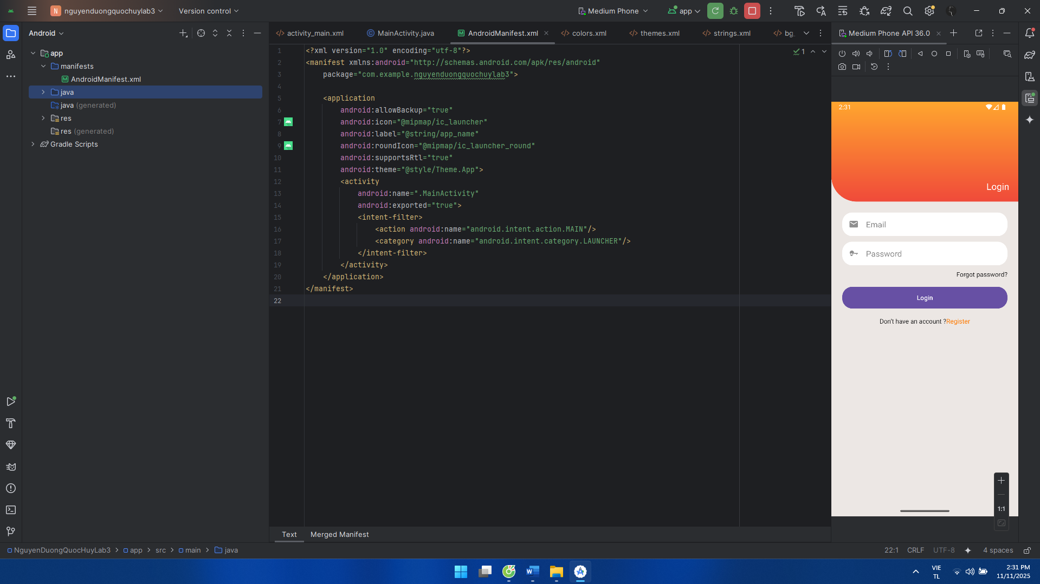

**Luyện tập 2: tạo giao diện menu:**

AndroidManifest:

<?xml version="1.0" encoding="utf-8"?>  
<manifest xmlns:android="http://schemas.android.com/apk/res/android"  
 package="com.example.nguyenduongquochuylab3">  
  
 <application  
 android:allowBackup="true"  
 android:icon="@mipmap/ic_launcher"  
 android:label="@string/app_name"  
 android:roundIcon="@mipmap/ic_launcher_round"  
 android:supportsRtl="true"  
 android:theme="@style/Theme.Vocab">  
 <activity  
 android:name=".MainActivity"  
 android:exported="true">  
 <intent-filter>  
 <action android:name="android.intent.action.MAIN"/>  
 <category android:name="android.intent.category.LAUNCHER"/>  
 </intent-filter>  
 </activity>  
 </application>  
</manifest>

DataProvider:

package com.example.nguyenduongquochuylab3;  
  
import java.util.ArrayList;  
import java.util.List;  
  
public class DataProvider {  
 public static List<Topic> getTopics() {  
 List<Topic> list = new ArrayList<>();  
 list.add(new Topic("Essentials"));  
 list.add(new Topic("While Traveling"));  
 list.add(new Topic("Help / Medical"));  
 list.add(new Topic("At the Hotel"));  
 list.add(new Topic("At the Restaurant"));  
 list.add(new Topic("At the Bar"));  
 list.add(new Topic("At the Store"));  
 list.add(new Topic("At Work"));  
 list.add(new Topic("Time, Date, Numbers"));  
 list.add(new Topic("Education"));  
 list.add(new Topic("Entertainment"));  
 return list;  
 }  
}

MainActivity:

package com.example.nguyenduongquochuylab3;  
  
import android.os.Bundle;  
import android.view.Menu;  
import android.view.MenuItem;  
  
import androidx.appcompat.app.AppCompatActivity;  
import androidx.appcompat.widget.Toolbar;  
import androidx.recyclerview.widget.LinearLayoutManager;  
import androidx.recyclerview.widget.RecyclerView;  
  
public class MainActivity extends AppCompatActivity {  
  
 @Override  
 protected void onCreate(Bundle savedInstanceState) {  
 super.onCreate(savedInstanceState);  
 setContentView(R.layout.*activity_main*);  
  
 Toolbar tb = findViewById(R.id.*toolbar*);  
 tb.setTitle(getString(R.string.*title_vocab*));  
 tb.setNavigationIcon(R.drawable.*ic_back*);  
 tb.setNavigationOnClickListener(v -> finish());  
 setSupportActionBar(tb);  
  
 RecyclerView rv = findViewById(R.id.*rvTopics*);  
 rv.setLayoutManager(new LinearLayoutManager(this));  
  
 TopicAdapter ad = new TopicAdapter(TopicStore.*TITLES*, TopicStore.*ICONS*);  
 rv.setAdapter(ad);  
 }  
  
 @Override  
 public boolean onCreateOptionsMenu(Menu menu) {  
 getMenuInflater().inflate(R.menu.*menu_main*, menu);  
 return true;  
 }  
 @Override  
 public boolean onOptionsItemSelected(MenuItem item) {  
 if (item.getItemId() == R.id.*act_search*) {return true;  
 }  
 return super.onOptionsItemSelected(item);  
 }  
}

Topic:

package com.example.nguyenduongquochuylab3;  
  
public class Topic {  
 public final String title;  
 public Topic(String title) { this.title = title; }  
}

TopicAdapter:

package com.example.nguyenduongquochuylab3;  
  
import android.view.LayoutInflater;  
import android.view.View;  
import android.view.ViewGroup;  
import android.widget.ImageView;  
import android.widget.TextView;  
  
import androidx.annotation.NonNull;  
import androidx.recyclerview.widget.RecyclerView;  
  
public class TopicAdapter extends RecyclerView.Adapter<TopicAdapter.VH> {  
 private final String[] titles;  
 private final int[] icons;  
  
 public TopicAdapter(String[] titles, int[] icons) {  
 this.titles = titles;  
 this.icons = icons;  
 }  
  
 @NonNull @Override  
 public VH onCreateViewHolder(@NonNull ViewGroup parent, int viewType) {  
 View v = LayoutInflater.*from*(parent.getContext()).inflate(R.layout.*item_topic*, parent, false);  
 return new VH(v);  
 }  
  
 @Override  
 public void onBindViewHolder(@NonNull VH h, int pos) {  
 h.tv.setText(titles[pos]);  
 int res = icons[pos];  
 if (res == 0) res = R.drawable.*ic_topic_dot*;  
 h.img.setImageResource(res);  
 }  
  
 @Override  
 public int getItemCount() { return titles.length; }  
  
 static class VH extends RecyclerView.ViewHolder {  
 ImageView img; TextView tv;  
 VH(@NonNull View v) { super(v);  
 img = v.findViewById(R.id.*imgIcon*);  
 tv = v.findViewById(R.id.*tvTitle*);  
 }  
 }  
}

TopicStore:

package com.example.nguyenduongquochuylab3;  
  
public final class TopicStore {  
 public static final String[] *TITLES* = new String[]{  
 "Essentials",  
 "While Traveling",  
 "Help / Medical",  
 "At the Hotel",  
 "At the Restaurant",  
 "At the Bar",  
 "At the Store",  
 "At Work",  
 "Time, Date, Numbers",  
 "Education",  
 "Entertainment"  
 };  
  
 public static final int[] *ICONS* = new int[]{  
 R.drawable.*ic_essentials*,  
 R.drawable.*ic_travel*,  
 R.drawable.*ic_medical*,  
 R.drawable.*ic_hotel*,  
 R.drawable.*ic_restaurant*,  
 R.drawable.*ic_bar*,  
 R.drawable.*ic_store*,  
 R.drawable.*ic_work*,  
 R.drawable.*ic_time*,  
 R.drawable.*ic_education*,  
 R.drawable.*ic_entertainment* };  
}

Thêm vào ở drawable:

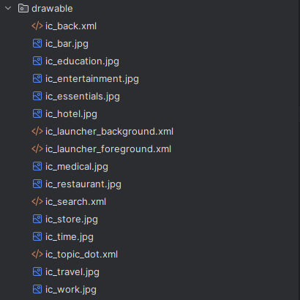

activity_main:

<?xml version="1.0" encoding="utf-8"?>  
<LinearLayout xmlns:android="http://schemas.android.com/apk/res/android"  
 android:layout_width="match_parent" android:layout_height="match_parent"  
 android:orientation="vertical" android:background="@color/white">  
  
 <androidx.appcompat.widget.Toolbar  
 android:id="@+id/toolbar"  
 android:layout_width="match_parent" android:layout_height="56dp"  
 android:background="@color/primary_600"  
 android:titleTextColor="@color/white" />  
  
 <androidx.recyclerview.widget.RecyclerView  
 android:id="@+id/rvTopics"  
 android:layout_width="match_parent" android:layout_height="match_parent"  
 android:paddingTop="4dp" android:paddingBottom="4dp"/>  
</LinearLayout>

item_topic:

<?xml version="1.0" encoding="utf-8"?>  
<RelativeLayout xmlns:android="http://schemas.android.com/apk/res/android"  
 android:layout_width="match_parent" android:layout_height="56dp"  
 android:paddingStart="12dp" android:paddingEnd="12dp"  
 android:background="@color/white">  
  
 <ImageView  
 android:id="@+id/imgIcon"  
 android:layout_width="28dp" android:layout_height="28dp"  
 android:layout_centerVertical="true"  
 android:src="@drawable/ic_topic_dot"/>  
  
 <TextView  
 android:id="@+id/tvTitle"  
 android:layout_width="wrap_content" android:layout_height="wrap_content"  
 android:layout_toRightOf="@id/imgIcon" android:layout_centerVertical="true"  
 android:layout_marginStart="12dp"  
 android:textColor="@color/title" android:textSize="16sp"  
 android:text="Essentials"/>  
  
 <View  
 android:layout_width="match_parent" android:layout_height="1dp"  
 android:background="@color/divider" android:layout_alignParentBottom="true"/>  
</RelativeLayout>

Giao diện:

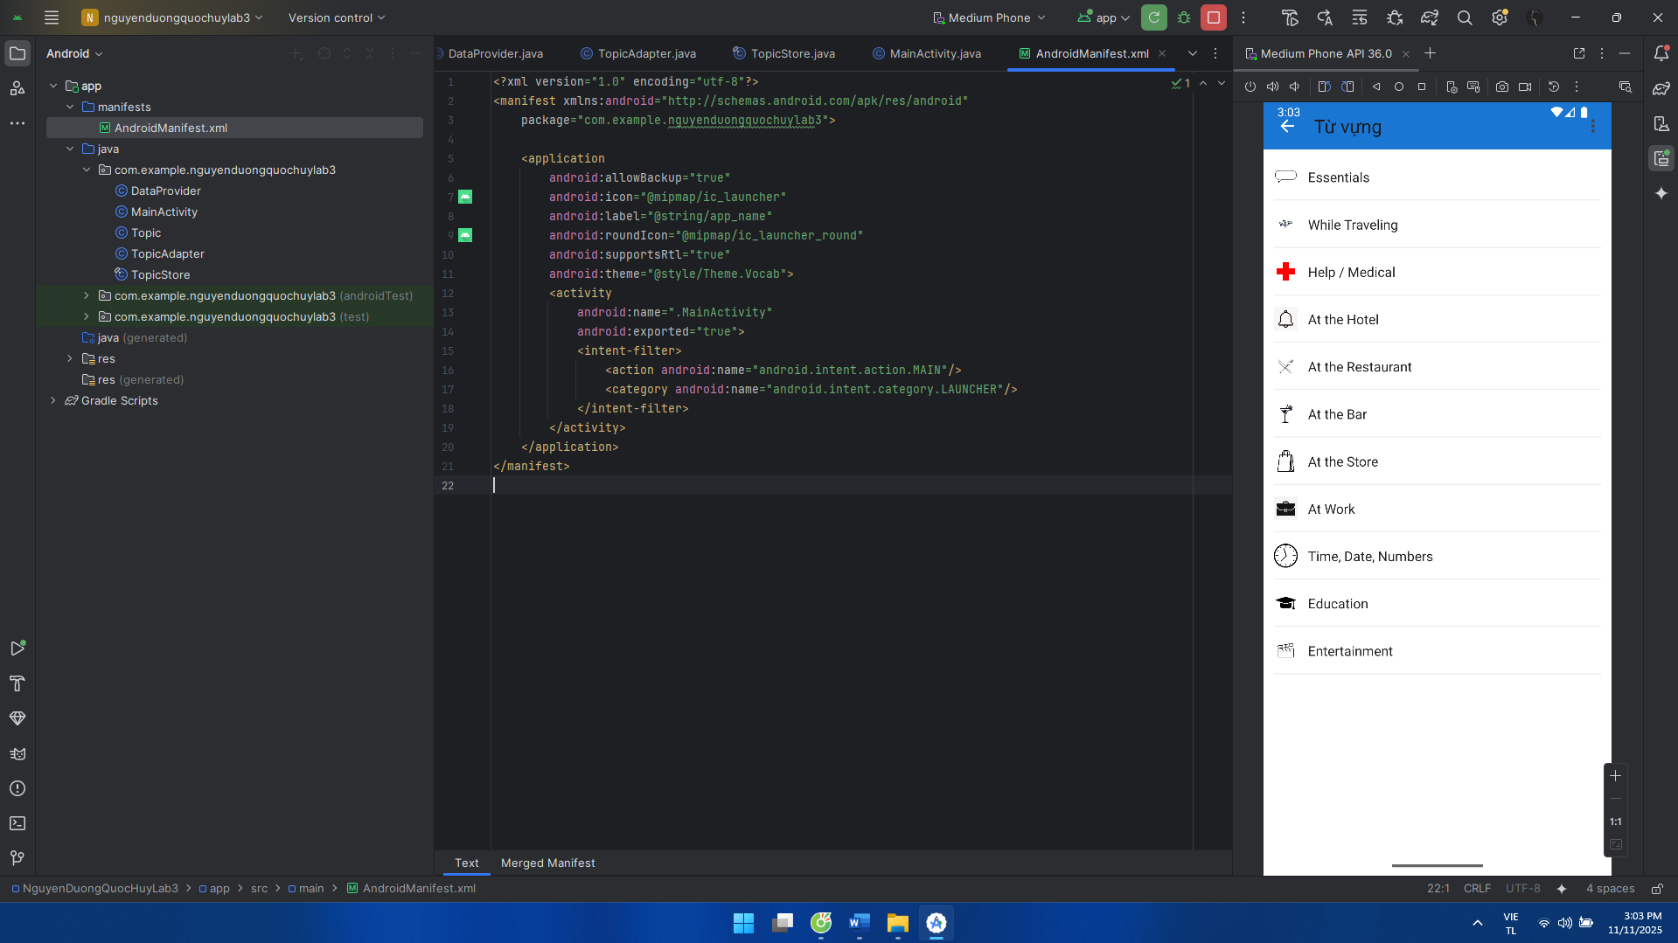

**Luyện tập 3: tạo giao diện Toast Emoij:**

AndroidManifest:

<?xml version="1.0" encoding="utf-8"?>  
<manifest xmlns:android="http://schemas.android.com/apk/res/android"  
 package="com.example.nguyenduongquochuylab3">  
  
 <application  
 android:allowBackup="true"  
 android:icon="@mipmap/ic_launcher"  
 android:label="@string/app_name"  
 android:roundIcon="@mipmap/ic_launcher_round"  
 android:supportsRtl="true"  
 android:theme="@style/Theme.FaceEmoji">  
 <activity  
 android:name=".MainActivity"  
 android:exported="true">  
 <intent-filter>  
 <action android:name="android.intent.action.MAIN"/>  
 <category android:name="android.intent.category.LAUNCHER"/>  
 </intent-filter>  
 </activity>  
 </application>  
</manifest>

EmojiAdapter:

package com.example.nguyenduongquochuylab3;  
  
import android.view.LayoutInflater;  
import android.view.View;  
import android.view.ViewGroup;  
import android.widget.TextView;  
  
import androidx.annotation.NonNull;  
import androidx.recyclerview.widget.RecyclerView;  
  
public class EmojiAdapter extends RecyclerView.Adapter<EmojiAdapter.VH> {  
  
 public interface OnEmojiClick { void onClick(String emoji); }  
  
 private final String[] data;  
 private final OnEmojiClick listener;  
  
 public EmojiAdapter(String[] data, OnEmojiClick listener) {  
 this.data = data;  
 this.listener = listener;  
 }  
  
 @NonNull @Override  
 public VH onCreateViewHolder(@NonNull ViewGroup parent, int viewType) {  
 View v = LayoutInflater.*from*(parent.getContext()).inflate(R.layout.*item_emoji*, parent, false);  
 return new VH(v);  
 }  
  
 @Override  
 public void onBindViewHolder(@NonNull VH h, int position) {  
 String e = data[position];  
 h.tv.setText(e);  
 h.itemView.setOnClickListener(v -> listener.onClick(e));  
 }  
  
 @Override  
 public int getItemCount() {  
 return data.length;  
 }  
  
 static class VH extends RecyclerView.ViewHolder {  
 TextView tv;  
 VH(@NonNull View itemView) {  
 super(itemView);  
 tv = itemView.findViewById(R.id.*tvEmoji*);  
 }  
 }  
}

EmojiFragment:

package com.example.nguyenduongquochuylab3;  
  
import android.os.Bundle;  
import android.view.LayoutInflater;  
import android.view.View;  
import android.view.ViewGroup;  
  
import androidx.annotation.NonNull;  
import androidx.annotation.Nullable;  
import androidx.fragment.app.Fragment;  
import androidx.recyclerview.widget.GridLayoutManager;  
import androidx.recyclerview.widget.RecyclerView;  
  
public class EmojiFragment extends Fragment implements EmojiAdapter.OnEmojiClick {  
  
 private final String[] EMOJIS = new String[]{  
 "😌","😎","😡",  
 "😂","😍","😜",  
 "😱","😴","🙂"  
 };  
  
 @Nullable  
 @Override  
 public View onCreateView(@NonNull LayoutInflater inflater, @Nullable ViewGroup container, @Nullable Bundle savedInstanceState) {  
 View v = inflater.inflate(R.layout.*fragment_emoji*, container, false);  
 RecyclerView rv = v.findViewById(R.id.*rvEmoji*);  
 rv.setLayoutManager(new GridLayoutManager(getContext(), 3));  
 rv.setAdapter(new EmojiAdapter(EMOJIS, this));  
 return v;  
 }  
  
 @Override  
 public void onClick(String emoji) {  
 if (getActivity() instanceof MainActivity) {  
 ((MainActivity) getActivity()).showEmojiToast(emoji);  
 }  
 }  
}

MainActivity:

package com.example.nguyenduongquochuylab3;  
  
import android.os.Bundle;  
import android.os.Handler;  
import android.view.View;  
import android.widget.TextView;  
  
import androidx.appcompat.app.AppCompatActivity;  
  
public class MainActivity extends AppCompatActivity {  
  
 private TextView emojiToast;  
 private final Handler handler = new Handler();  
  
 @Override  
 protected void onCreate(Bundle savedInstanceState) {  
 super.onCreate(savedInstanceState);  
 setContentView(R.layout.*activity_main*);  
 emojiToast = findViewById(R.id.*emojiToast*);  
  
 getSupportFragmentManager()  
 .beginTransaction()  
 .replace(R.id.*fragment_container*, new EmojiFragment())  
 .commit();  
 }  
  
 public void showEmojiToast(String emoji) {  
 emojiToast.setText(emoji);  
 emojiToast.setVisibility(View.*VISIBLE*);  
 emojiToast.animate().alpha(1f).setDuration(150).start();  
 handler.removeCallbacksAndMessages(null);  
 handler.postDelayed(() -> {  
 emojiToast.animate().alpha(0f).setDuration(200).withEndAction(() -> {  
 emojiToast.setVisibility(View.*GONE*);  
 }).start();  
 }, 1500);  
 }  
}

bg_emoji:

<?xml version="1.0" encoding="utf-8"?>  
<shape xmlns:android="http://schemas.android.com/apk/res/android">  
 <solid android:color="@color/emoji_yellow"/>  
 <corners android:radius="16dp"/>  
 <stroke android:width="1dp" android:color="@color/emoji_border"/>  
</shape>

activity_main:

<?xml version="1.0" encoding="utf-8"?>  
<FrameLayout xmlns:android="http://schemas.android.com/apk/res/android"  
 android:layout_width="match_parent" android:layout_height="match_parent"  
 android:background="@color/bg">  
  
 <LinearLayout  
 android:layout_width="match_parent" android:layout_height="match_parent"  
 android:orientation="vertical">  
  
 <TextView  
 android:id="@+id/tvHeader"  
 android:layout_width="match_parent" android:layout_height="48dp"  
 android:gravity="center_vertical"  
 android:paddingLeft="16dp"  
 android:text="@string/title_face_emoji"  
 android:textColor="@color/white" android:textStyle="bold"  
 android:background="@color/primary"/>  
  
 <FrameLayout  
 android:id="@+id/fragment_container"  
 android:layout_width="match_parent" android:layout_height="0dp"  
 android:layout_weight="1"/>  
 </LinearLayout>  
  
 <TextView  
 android:id="@+id/emojiToast"  
 android:layout_width="64dp" android:layout_height="64dp"  
 android:layout_gravity="bottom|end"  
 android:layout_margin="16dp"  
 android:gravity="center"  
 android:background="@drawable/bg_emoji"  
 android:textSize="28sp"  
 android:alpha="0"  
 android:visibility="gone"/>  
</FrameLayout>

fragment_emoji:

<?xml version="1.0" encoding="utf-8"?>  
<LinearLayout xmlns:android="http://schemas.android.com/apk/res/android"  
 android:layout_width="match_parent" android:layout_height="match_parent"  
 android:padding="12dp">  
  
 <androidx.recyclerview.widget.RecyclerView  
 android:id="@+id/rvEmoji"  
 android:layout_width="match_parent" android:layout_height="match_parent"/>  
</LinearLayout>

item_emoji:

<?xml version="1.0" encoding="utf-8"?>  
<androidx.constraintlayout.widget.ConstraintLayout  
 xmlns:android="http://schemas.android.com/apk/res/android"  
 xmlns:app="http://schemas.android.com/apk/res-auto"  
 android:layout_width="match_parent" android:layout_height="wrap_content">  
  
 <TextView  
 android:id="@+id/tvEmoji"  
 android:layout_width="0dp" android:layout_height="0dp"  
 android:layout_margin="8dp"  
 android:background="@drawable/bg_emoji"  
 android:gravity="center"  
 android:textSize="28sp"  
 app:layout_constraintTop_toTopOf="parent"  
 app:layout_constraintBottom_toBottomOf="parent"  
 app:layout_constraintStart_toStartOf="parent"  
 app:layout_constraintEnd_toEndOf="parent"  
 app:layout_constraintDimensionRatio="1:1"/>  
</androidx.constraintlayout.widget.ConstraintLayout>

Giao diện:

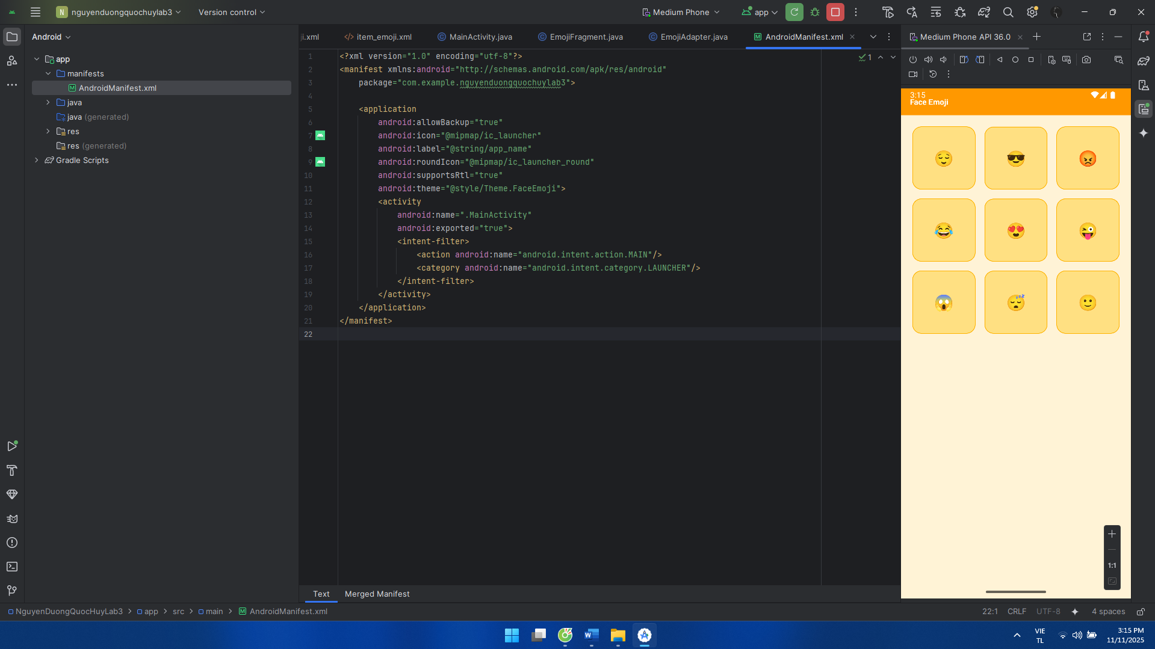

**Bài tập 1:**

Từ luyện tập 1 chúng ta tiến hành thêm toast  
MainActivity:

package com.example.nguyenduongquochuylab3;  
  
import android.os.Bundle;  
import android.view.Gravity;  
import android.view.LayoutInflater;  
import android.view.View;  
import android.widget.Button;  
import android.widget.EditText;  
import android.widget.TextView;  
import android.widget.Toast;  
  
import androidx.appcompat.app.AppCompatActivity;  
  
public class MainActivity extends AppCompatActivity {  
  
 EditText edtEmail, edtPassword;  
 Button btnLogin;  
 TextView tvForgot, tvRegister;  
  
 @Override  
 protected void onCreate(Bundle savedInstanceState) {  
 super.onCreate(savedInstanceState);  
 setContentView(R.layout.*activity_main*);  
  
 edtEmail = findViewById(R.id.*edtEmail*);  
 edtPassword= findViewById(R.id.*edtPassword*);  
 btnLogin = findViewById(R.id.*btnLogin*);  
 tvForgot = findViewById(R.id.*tvForgot*);  
 tvRegister = findViewById(R.id.*tvRegister*);  
  
 btnLogin.setOnClickListener(v -> {  
 String email = edtEmail.getText().toString().trim();  
 String pass = edtPassword.getText().toString();  
  
 if (email.isEmpty() || pass.isEmpty()) {  
 showCustomToast("Vui lòng nhập đầy đủ email và mật khẩu");  
 return;  
 }  
  
 String msg = "Bạn đã đăng nhập thành công với email: " + email  
 + " và mật khẩu " + pass;  
 showCustomToast(msg);  
 });  
  
 tvForgot.setOnClickListener(v -> showCustomToast("Quên mật khẩu?"));  
 tvRegister.setOnClickListener(v -> showCustomToast("Đi tới đăng ký"));  
 }  
private void showCustomToast(String message) {  
 LayoutInflater inflater = getLayoutInflater();  
 View layout = inflater.inflate(R.layout.*view_toast*, findViewById(R.id.*toastRoot*));  
 TextView tv = layout.findViewById(R.id.*tvToast*);  
 tv.setText(message);  
  
 Toast t = new Toast(getApplicationContext());  
 t.setGravity(Gravity.*TOP* | Gravity.*CENTER_HORIZONTAL*, 0, 140); // vị trí trên giữa  
 t.setDuration(Toast.*LENGTH_LONG*);  
 t.setView(layout);  
 t.show();  
 }  
}

bg_toast:

<?xml version="1.0" encoding="utf-8"?>  
<shape xmlns:android="http://schemas.android.com/apk/res/android">  
 <gradient android:startColor="#FF7A00" android:endColor="#F04A3A" android:angle="0" />  
 <corners android:radius="16dp"/>  
 <padding android:left="14dp" android:top="10dp" android:right="14dp" android:bottom="10dp"/>  
</shape>

view_toast:

<?xml version="1.0" encoding="utf-8"?>  
<LinearLayout xmlns:android="http://schemas.android.com/apk/res/android"  
 android:id="@+id/toastRoot"  
 android:layout_width="wrap_content"  
 android:layout_height="wrap_content"  
 android:background="@drawable/bg_toast"  
 android:padding="14dp"  
 android:orientation="horizontal"  
 android:gravity="center_vertical">  
  
 <ImageView  
 android:layout_width="20dp"  
 android:layout_height="20dp"  
 android:tint="@android:color/white"  
 android:src="@android:drawable/ic_dialog_info" />  
  
 <TextView  
 android:id="@+id/tvToast"  
 android:layout_width="wrap_content"  
 android:layout_height="wrap_content"  
 android:paddingStart="10dp"  
 android:textColor="@android:color/white"  
 android:textSize="14sp"  
 android:text="Message"/>  
</LinearLayout>

Giao diện:

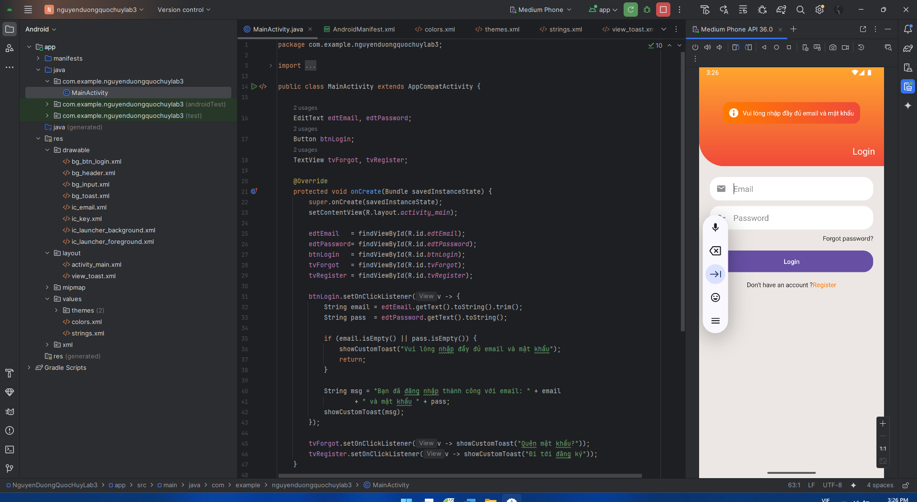

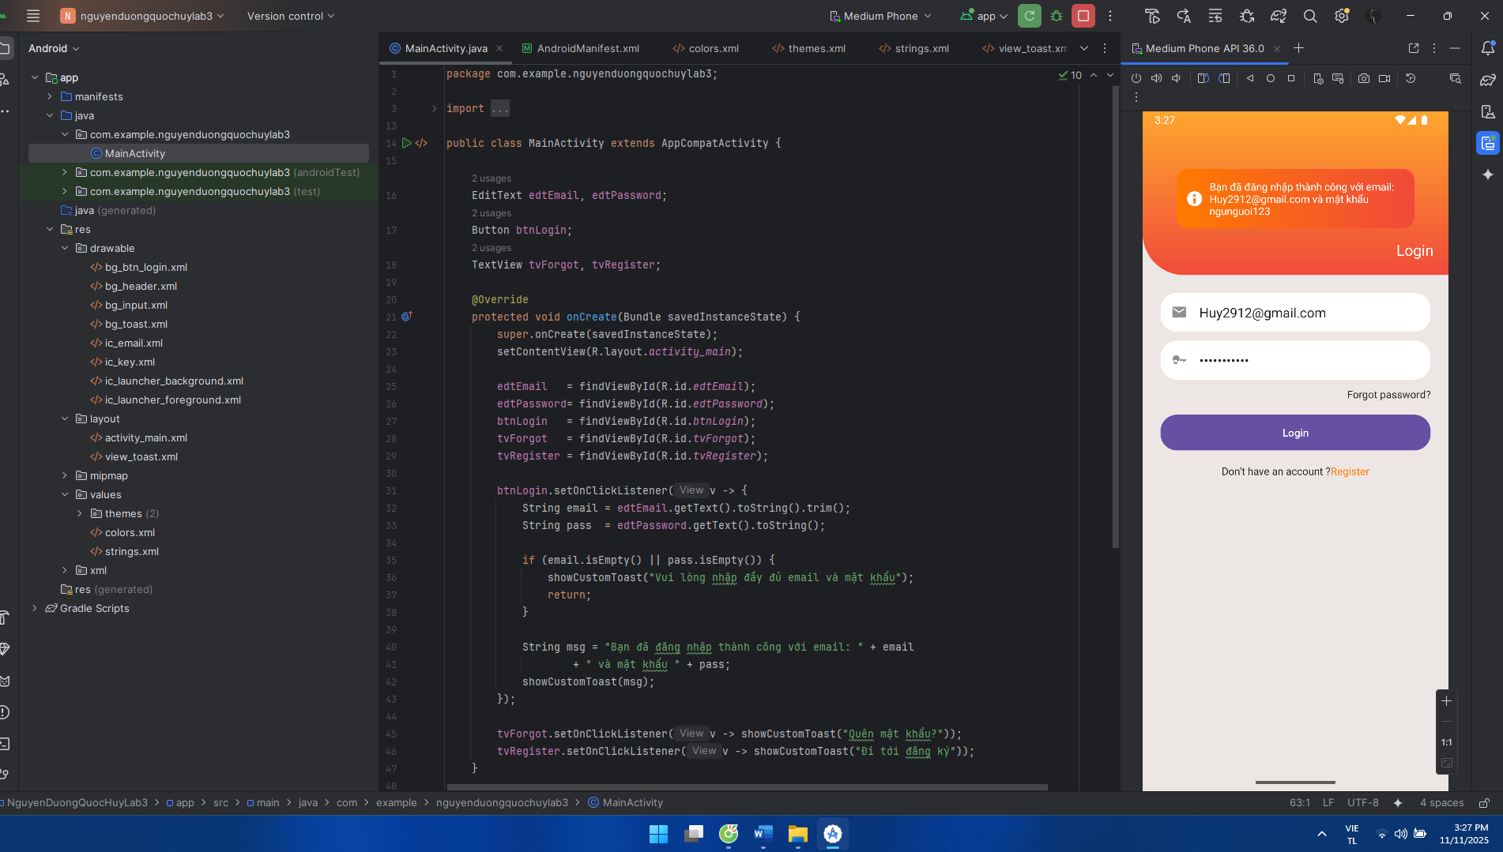

**Bài Tập 2:**

Từ luyện tập 2 chúng ta tiến hành thêm toast và listview

AndroidManifest thêm:

<activity  
 android:name=".VocabActivity"  
 android:exported="false" />

DataProvider:

package com.example.nguyenduongquochuylab3;  
  
import java.util.ArrayList;  
import java.util.List;  
  
public class DataProvider {  
 public static List<Topic> getTopics() {  
 List<Topic> list = new ArrayList<>();  
 list.add(new Topic("Essentials"));  
 list.add(new Topic("While Traveling"));  
 list.add(new Topic("Help / Medical"));  
 list.add(new Topic("At the Hotel"));  
 list.add(new Topic("At the Restaurant"));  
 list.add(new Topic("At the Bar"));  
 list.add(new Topic("At the Store"));  
 list.add(new Topic("At Work"));  
 list.add(new Topic("Time, Date, Numbers"));  
 list.add(new Topic("Education"));  
 list.add(new Topic("Entertainment"));  
 return list;  
 }  
}

TopicStore (thêm listener click và long-click) :

private static final String[][] *WORDS* = new String[][]{  
 {"hello", "please", "thank you", "sorry", "excuse me", "goodbye"},  
 {"ticket", "platform", "luggage", "passport", "boarding pass"},  
 {"doctor", "nurse", "medicine", "hospital", "first aid"},  
 {"reception", "reservation", "key card", "lobby", "check-out"},  
 {"menu", "waiter", "bill", "table", "spicy", "delicious"},  
 {"beer", "wine", "cheers", "ice", "glass"},  
 {"cashier", "discount", "receipt", "queue", "fitting room"},  
 {"meeting", "deadline", "report", "salary", "colleague"},  
 {"o'clock", "minute", "calendar", "yesterday", "hundred"},  
 {"student", "teacher", "exam", "classroom", "homework"},  
 {"movie", "music", "concert", "game", "theater"}  
};  
  
public static String[] getWords(int index) {  
 if (index < 0 || index >= *WORDS*.length) return new String[0];  
 return *WORDS*[index];  
}

TopicAdapter thêm:

public interface OnTopicListener {  
 void onClick(int position);  
 void onLongClick(int position);  
}

MainActivity thêm (click = Toast, long-click = mở Activity):

@Override  
protected void onCreate(Bundle savedInstanceState) {  
 super.onCreate(savedInstanceState);  
 setContentView(R.layout.*activity_main*);  
  
 Toolbar tb = findViewById(R.id.*toolbar*);  
 tb.setTitle(getString(R.string.*title_vocab*));  
 tb.setNavigationIcon(R.drawable.*ic_back*);  
 tb.setNavigationOnClickListener(v -> finish());  
 setSupportActionBar(tb);  
  
 RecyclerView rv = findViewById(R.id.*rvTopics*);  
 rv.setLayoutManager(new LinearLayoutManager(this));  
  
 TopicAdapter ad = new TopicAdapter(  
 TopicStore.*TITLES*,  
 TopicStore.*ICONS*,  
 new TopicAdapter.OnTopicListener() {  
 @Override  
 public void onClick(int position) {  
 String[] words = TopicStore.*getWords*(position);  
 String msg = words.length == 0 ? "No words"  
 : String.*join*(", ",  
 Arrays.*copyOfRange*(words, 0, Math.*min*(5, words.length)));  
 Toast.*makeText*(MainActivity.this, msg, Toast.*LENGTH_SHORT*).show();  
 }  
  
 @Override  
 public void onLongClick(int position) {  
 Intent i = new Intent(MainActivity.this, VocabActivity.class);  
 i.putExtra("title", TopicStore.*TITLES*[position]);  
 i.putExtra("index", position);  
 startActivity(i);  
 }  
 }  
 );  
 rv.setAdapter(ad);  
}

VocabActivity;

package com.example.nguyenduongquochuylab3;  
  
import android.os.Bundle;  
import android.widget.ArrayAdapter;  
import android.widget.ListView;  
  
import androidx.appcompat.app.AppCompatActivity;  
import androidx.appcompat.widget.Toolbar;  
  
public class VocabActivity extends AppCompatActivity {  
  
 @Override  
 protected void onCreate(Bundle savedInstanceState) {  
 super.onCreate(savedInstanceState);  
 setContentView(R.layout.*activity_vocab*);  
  
 String title = getIntent().getStringExtra("title");  
 int index = getIntent().getIntExtra("index", 0);  
  
 Toolbar tb = findViewById(R.id.*toolbar_vocab*);  
 tb.setTitle(title);  
 tb.setNavigationIcon(R.drawable.*ic_back*);  
 tb.setNavigationOnClickListener(v -> finish());  
 setSupportActionBar(tb);  
  
 ListView lv = findViewById(R.id.*lvWords*);  
 String[] words = TopicStore.*getWords*(index);  
 lv.setAdapter(new ArrayAdapter<>(this, android.R.layout.*simple_list_item_1*, words));  
 }  
}

activity_vocab:

<?xml version="1.0" encoding="utf-8"?>  
<LinearLayout xmlns:android="http://schemas.android.com/apk/res/android"  
 android:layout_width="match_parent" android:layout_height="match_parent"  
 android:orientation="vertical">  
  
 <androidx.appcompat.widget.Toolbar  
 android:id="@+id/toolbar_vocab"  
 android:layout_width="match_parent" android:layout_height="56dp"  
 android:background="@color/primary_600"  
 android:titleTextColor="@color/white"/>  
  
 <ListView  
 android:id="@+id/lvWords"  
 android:layout_width="match_parent" android:layout_height="match_parent"  
 android:divider="@color/divider"  
 android:dividerHeight="1dp"/>  
</LinearLayout>

Giao diện:

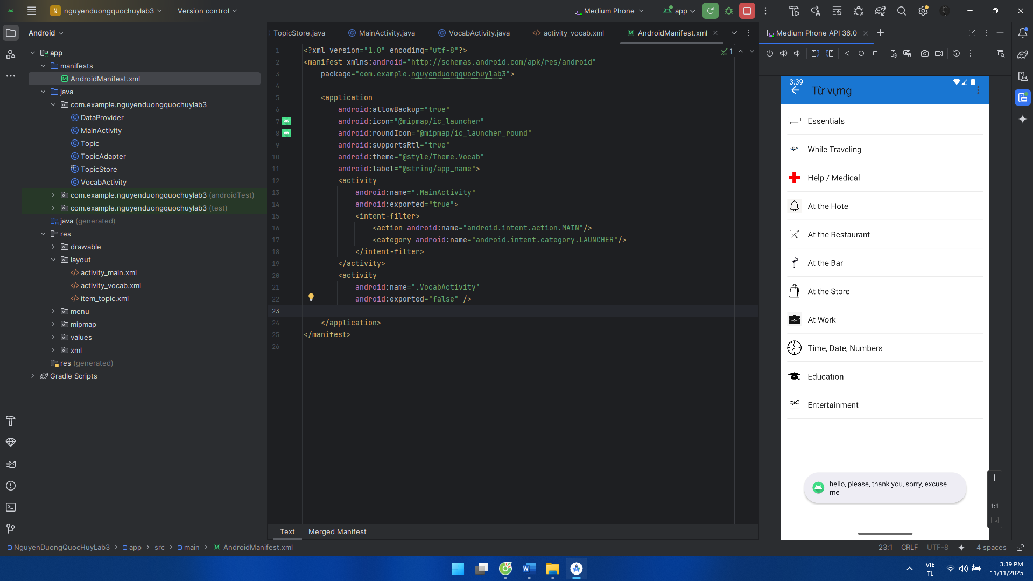

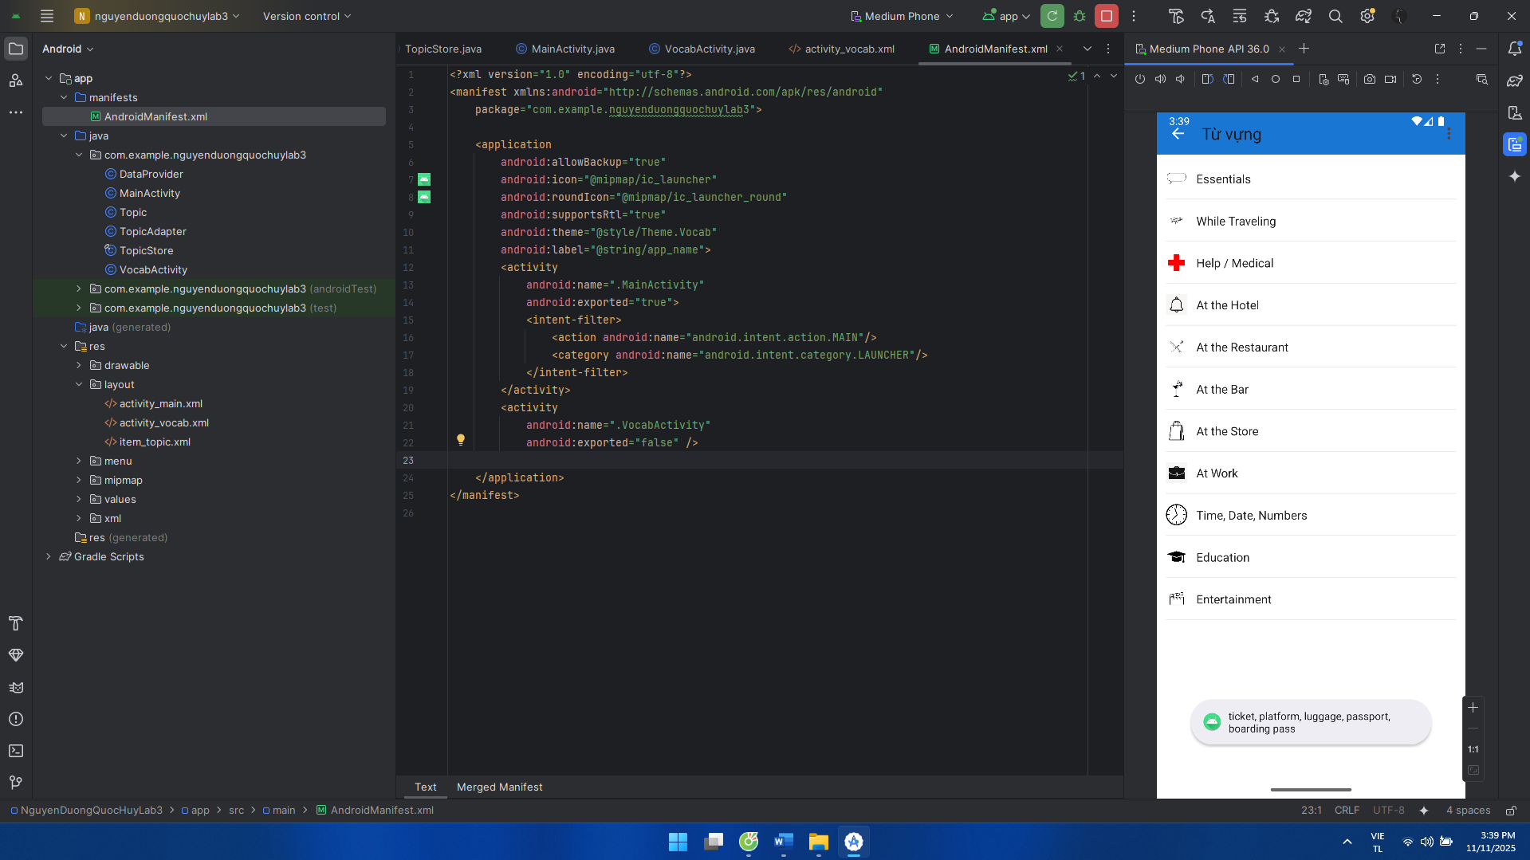

**Bài Tập 3:**

Từ luyện tập 3 chúng ta tiến hành thêm random

Strings:

<string name="random">Random</string>

activity_main:

<LinearLayout  
 android:layout_width="match_parent" android:layout_height="wrap_content"  
 android:orientation="horizontal" android:padding="12dp">  
 <Button  
 android:id="@+id/btnRandom"  
 android:layout_width="wrap_content" android:layout_height="40dp"  
 android:text="@string/random" />  
</LinearLayout>

MainActivity:

@Override  
protected void onCreate(Bundle savedInstanceState) {  
 super.onCreate(savedInstanceState);  
 setContentView(R.layout.*activity_main*);  
  
 emojiToast = findViewById(R.id.*emojiToast*);  
 Button btnRandom = findViewById(R.id.*btnRandom*);  
  
 EmojiFragment frag = new EmojiFragment();  
 getSupportFragmentManager()  
 .beginTransaction()  
 .replace(R.id.*fragment_container*, frag, *FRAG_TAG*)  
 .commit();  
  
 btnRandom.setOnClickListener(v -> {  
 Fragment f = getSupportFragmentManager().findFragmentByTag(*FRAG_TAG*);  
 if (f instanceof EmojiFragment) {  
 ((EmojiFragment) f).randomize();  
 }  
 });  
}

EmojiFragment:

public void randomize() {  
 current = pick9();  
 adapter.setData(current);  
}  
  
private String[] pick9() {  
 List<String> list = new ArrayList<>();  
 Collections.*addAll*(list, SOURCE);  
 Collections.*shuffle*(list);  
 String[] out = new String[9];  
 for (int i = 0; i < 9; i++) out[i] = list.get(i);  
 return out;  
}  
  
@Override  
public void onClick(String emoji) {  
 if (getActivity() instanceof MainActivity) {  
 ((MainActivity) getActivity()).showEmojiToast(emoji);  
 }  
}

EmojiAdapter:

package com.example.nguyenduongquochuylab3;  
  
import android.view.LayoutInflater;  
import android.view.View;  
import android.view.ViewGroup;  
import android.widget.TextView;  
  
import androidx.annotation.NonNull;  
import androidx.recyclerview.widget.RecyclerView;  
  
public class EmojiAdapter extends RecyclerView.Adapter<EmojiAdapter.VH> {  
  
 public interface OnEmojiClick { void onClick(String emoji); }  
  
 private String[] data;  
 private final OnEmojiClick listener;  
  
 public EmojiAdapter(String[] data, OnEmojiClick listener) {  
 this.data = data;  
 this.listener = listener;  
 }  
  
 public void setData(String[] newData) {  
 this.data = newData;  
 notifyDataSetChanged();  
 }  
  
 @NonNull @Override  
 public VH onCreateViewHolder(@NonNull ViewGroup parent, int viewType) {  
 View v = LayoutInflater.*from*(parent.getContext()).inflate(R.layout.*item_emoji*, parent, false);  
 return new VH(v);  
 }  
  
 @Override  
 public void onBindViewHolder(@NonNull VH h, int position) {  
 String e = data[position];  
 h.tv.setText(e);  
 h.itemView.setOnClickListener(v -> listener.onClick(e));  
 }  
  
 @Override  
 public int getItemCount() {  
 return data.length;  
 }  
  
 static class VH extends RecyclerView.ViewHolder {  
 TextView tv;  
 VH(@NonNull View itemView) {  
 super(itemView);  
 tv = itemView.findViewById(R.id.*tvEmoji*);  
 }  
 }  
}

Giao diện:

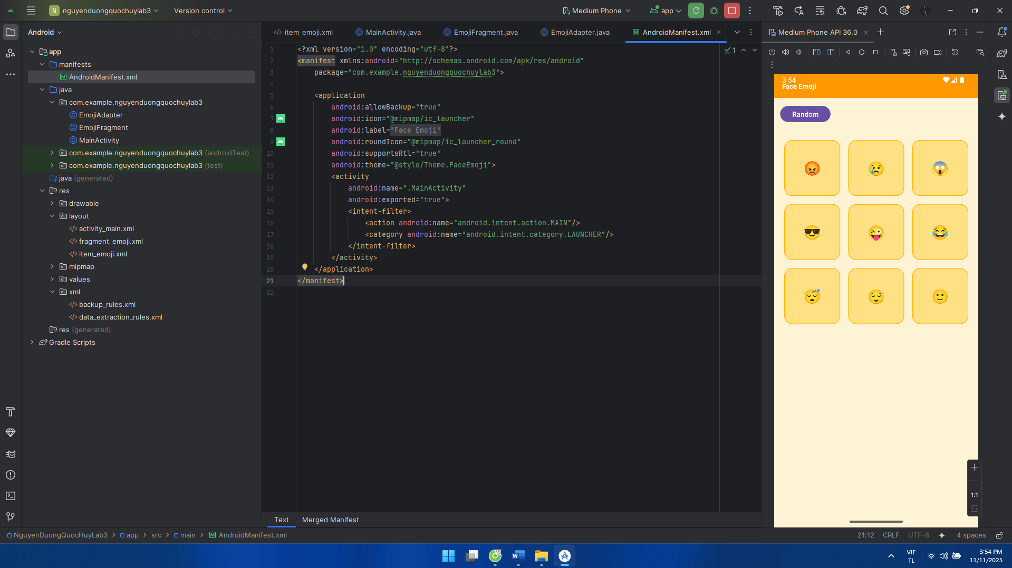

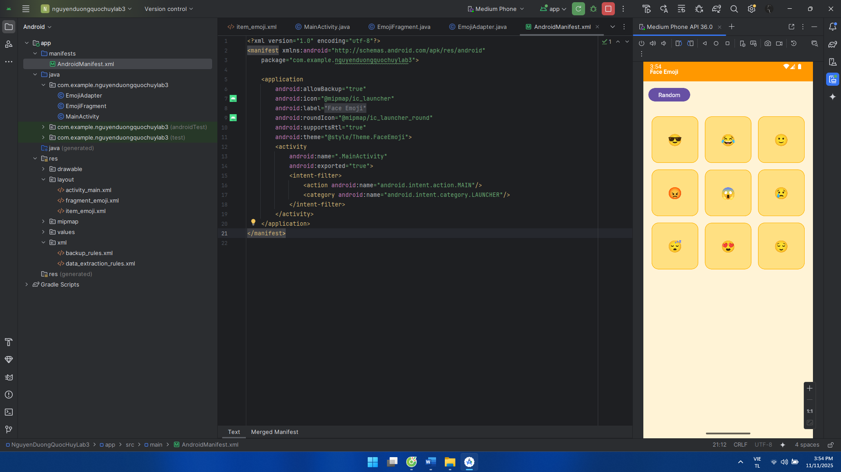

**LAB 5**

**Luyện tập 1: xử lý animation trong layout**

AndroidManifest:

<?xml version="1.0" encoding="utf-8"?>  
<manifest xmlns:android="http://schemas.android.com/apk/res/android"  
 package="com.example.nguyenduongquochuylab3">  
  
 <application  
 android:allowBackup="true"  
 android:icon="@mipmap/ic_launcher"  
 android:label="@string/app_name"  
 android:roundIcon="@mipmap/ic_launcher_round"  
 android:supportsRtl="true"  
 android:theme="@style/Theme.AnimDemo">  
 <activity  
 android:name=".MainActivity"  
 android:exported="true">  
 <intent-filter>  
 <action android:name="android.intent.action.MAIN"/>  
 <category android:name="android.intent.category.LAUNCHER"/>  
 </intent-filter>  
 </activity>  
 </application>  
</manifest>

Strings:

<resources>  
 <string name="app_name">Face Animation</string>  
 <string name="title">Face Animation</string>  
 <string name="alpha">ALPHA</string>  
 <string name="scale">SCALE</string>  
 <string name="trans">TRANS</string>  
 <string name="rotate">ROTATE</string>  
</resources>

bg_btn:

<?xml version="1.0" encoding="utf-8"?>  
<shape xmlns:android="http://schemas.android.com/apk/res/android">  
 <solid android:color="@color/purple_600"/>  
 <corners android:radius="16dp"/>  
 <padding android:left="18dp" android:top="10dp" android:right="18dp" android:bottom="10dp"/>  
</shape>

Elephant.jpg:



activity_main:

<?xml version="1.0" encoding="utf-8"?>  
<LinearLayout xmlns:android="http://schemas.android.com/apk/res/android"  
 android:layout_width="match_parent"  
 android:layout_height="match_parent"  
 android:orientation="vertical"  
 android:background="@color/bg">  
  
 <TextView  
 android:id="@+id/tvHeader"  
 android:layout_width="match_parent"  
 android:layout_height="56dp"  
 android:background="@color/purple_600"  
 android:gravity="center_vertical"  
 android:paddingStart="16dp"  
 android:text="@string/title"  
 android:textColor="@color/white"  
 android:textStyle="bold" />  
  
 <LinearLayout  
 android:layout_width="match_parent"  
 android:layout_height="0dp"  
 android:layout_weight="1"  
 android:orientation="vertical"  
 android:padding="20dp">  
  
 <ImageView  
 android:id="@+id/imgFace"  
 android:layout_width="180dp"  
 android:layout_height="180dp"  
 android:layout_gravity="center"  
 android:src="@drawable/elephant"  
 android:contentDescription="@string/title" />  
  
 <LinearLayout  
 android:layout_width="match_parent"  
 android:layout_height="wrap_content"  
 android:layout_marginTop="32dp"  
 android:orientation="horizontal"  
 android:gravity="center"  
 android:weightSum="4">  
  
 <Button  
 android:id="@+id/btnAlpha"  
 android:layout_width="0dp"  
 android:layout_height="48dp"  
 android:layout_weight="1"  
 android:layout_marginEnd="12dp"  
 android:background="@drawable/bg_btn"  
 android:maxLines="1"  
 android:text="@string/alpha"  
 android:textAllCaps="true"  
 android:textColor="@color/white" />  
  
 <Button  
 android:id="@+id/btnScale"  
 android:layout_width="0dp"  
 android:layout_height="48dp"  
 android:layout_weight="1"  
 android:layout_marginEnd="12dp"  
 android:background="@drawable/bg_btn"  
 android:maxLines="1"  
 android:text="@string/scale"  
 android:textAllCaps="true"  
 android:textColor="@color/white" />  
  
 <Button  
 android:id="@+id/btnTrans"  
 android:layout_width="0dp"  
 android:layout_height="48dp"  
 android:layout_weight="1"  
 android:layout_marginEnd="12dp"  
 android:background="@drawable/bg_btn"  
 android:maxLines="1"  
 android:text="@string/trans"  
 android:textAllCaps="true"  
 android:textColor="@color/white" />  
  
 <Button  
 android:id="@+id/btnRotate"  
 android:layout_width="0dp"  
 android:layout_height="48dp"  
 android:layout_weight="1"  
 android:background="@drawable/bg_btn"  
 android:maxLines="1"  
 android:text="@string/rotate"  
 android:textAllCaps="true"  
 android:textColor="@color/white" />  
 </LinearLayout>  
 </LinearLayout>  
</LinearLayout>

MainActivity:

package com.example.nguyenduongquochuylab3;  
  
import android.animation.ObjectAnimator;  
import android.animation.PropertyValuesHolder;  
import android.animation.ValueAnimator;  
import android.os.Bundle;  
import android.view.View;  
import android.widget.Button;  
import android.widget.ImageView;  
  
import androidx.appcompat.app.AppCompatActivity;  
  
public class MainActivity extends AppCompatActivity {  
  
 ImageView img;  
 Button bAlpha, bScale, bTrans, bRotate;  
  
 ObjectAnimator alphaAnim, scaleAnim, transAnim, rotateAnim;  
  
 @Override  
 protected void onCreate(Bundle savedInstanceState) {  
 super.onCreate(savedInstanceState);  
 setContentView(R.layout.*activity_main*);  
  
 img = findViewById(R.id.*imgFace*);  
 bAlpha = findViewById(R.id.*btnAlpha*);  
 bScale = findViewById(R.id.*btnScale*);  
 bTrans = findViewById(R.id.*btnTrans*);  
 bRotate = findViewById(R.id.*btnRotate*);  
  
 alphaAnim = ObjectAnimator.*ofFloat*(img, View.*ALPHA*, 1f, 0.3f, 1f);  
 alphaAnim.setDuration(900);  
 alphaAnim.setRepeatCount(ValueAnimator.*INFINITE*);  
  
 PropertyValuesHolder sx = PropertyValuesHolder.*ofFloat*(View.*SCALE_X*, 1f, 1.25f, 1f);  
 PropertyValuesHolder sy = PropertyValuesHolder.*ofFloat*(View.*SCALE_Y*, 1f, 1.25f, 1f);  
 scaleAnim = ObjectAnimator.*ofPropertyValuesHolder*(img, sx, sy);  
 scaleAnim.setDuration(900);  
 scaleAnim.setRepeatCount(ValueAnimator.*INFINITE*);  
  
 transAnim = ObjectAnimator.*ofFloat*(img, View.*TRANSLATION_X*, 0f, 60f, -60f, 0f);  
 transAnim.setDuration(1200);  
 transAnim.setRepeatCount(ValueAnimator.*INFINITE*);  
  
 rotateAnim = ObjectAnimator.*ofFloat*(img, View.*ROTATION*, 0f, 360f);  
 rotateAnim.setDuration(1200);  
 rotateAnim.setRepeatCount(ValueAnimator.*INFINITE*);  
  
 bAlpha.setOnClickListener(v -> toggle(alphaAnim));  
 bScale.setOnClickListener(v -> toggle(scaleAnim));  
 bTrans.setOnClickListener(v -> toggle(transAnim));  
 bRotate.setOnClickListener(v -> toggle(rotateAnim));  
 }  
  
 private void toggle(ObjectAnimator a) {  
 if (a.isRunning()) a.cancel(); else a.start();  
 }  
}

Giao diện:

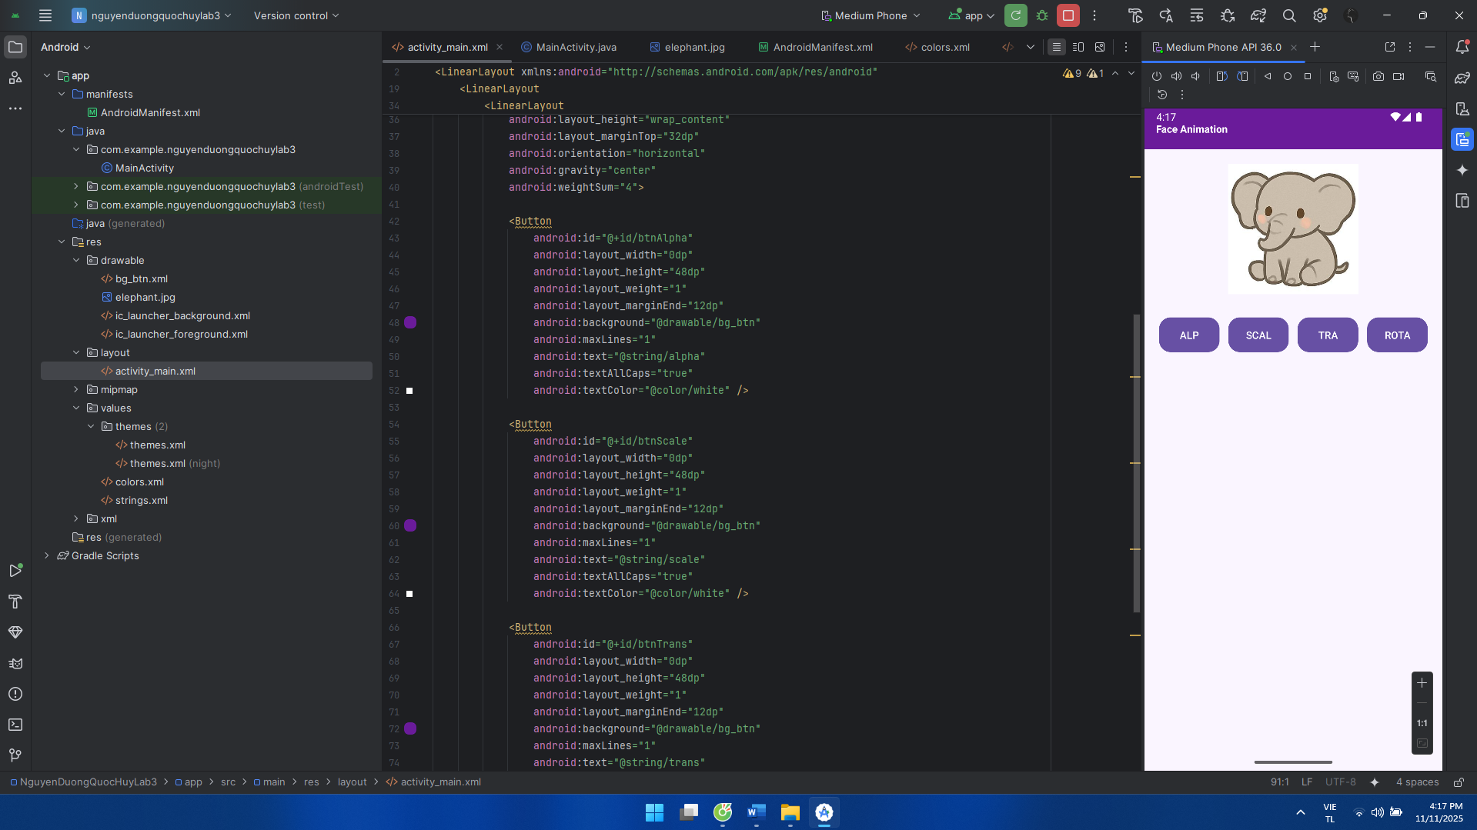

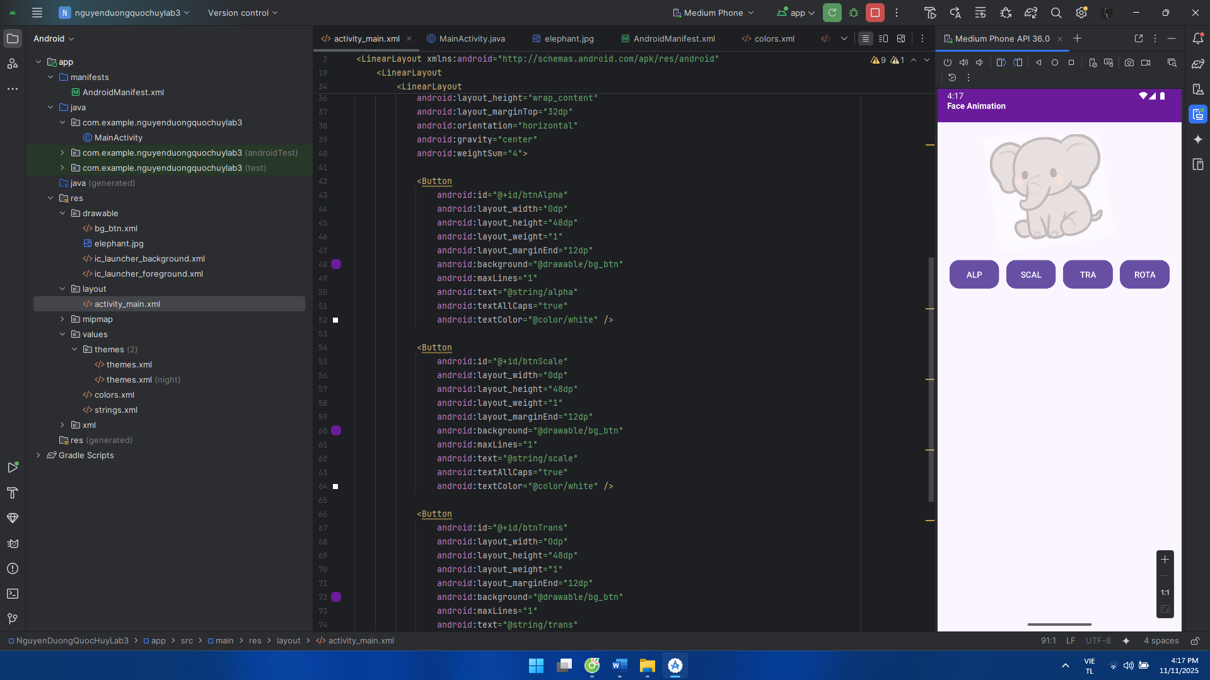

**Luyện tập 2: Xây dựng ứng dụng QuickCall (1) và (2):**

AndroidManifest:

<?xml version="1.0" encoding="utf-8"?>  
<manifest xmlns:android="http://schemas.android.com/apk/res/android"  
 package="com.example.nguyenduongquochuylab3">  
  
 <application  
 android:allowBackup="true"  
 android:icon="@mipmap/ic_launcher"  
 android:label="@string/app_name"  
 android:roundIcon="@mipmap/ic_launcher_round"  
 android:supportsRtl="true"  
 android:theme="@style/Theme.QuickCall">  
 <activity  
 android:name=".MainActivity"  
 android:exported="true">  
 <intent-filter>  
 <action android:name="android.intent.action.MAIN"/>  
 <category android:name="android.intent.category.LAUNCHER"/>  
 </intent-filter>  
 </activity>  
 </application>  
</manifest>

MainActivity:

package com.example.nguyenduongquochuylab3;  
  
import android.content.Intent;  
import android.net.Uri;  
import android.os.Bundle;  
import android.view.Menu;  
import android.view.MenuItem;  
import android.widget.LinearLayout;  
  
import androidx.appcompat.app.AppCompatActivity;  
import androidx.appcompat.widget.Toolbar;  
  
public class MainActivity extends AppCompatActivity {  
  
 LinearLayout rowMom, rowDad, rowCrush, rowBest;  
  
 @Override  
 protected void onCreate(Bundle savedInstanceState) {  
 super.onCreate(savedInstanceState);  
 setContentView(R.layout.*activity_main*);  
  
 Toolbar tb = findViewById(R.id.*toolbar*);  
 tb.setTitle(getString(R.string.*title_quickcall*));  
 setSupportActionBar(tb);  
  
 rowMom = findViewById(R.id.*rowMom*);  
 rowDad = findViewById(R.id.*rowDad*);  
 rowCrush = findViewById(R.id.*rowCrush*);  
 rowBest = findViewById(R.id.*rowBest*);  
  
 rowMom.setOnClickListener(v -> dial(getString(R.string.*tel_mom*)));  
 rowDad.setOnClickListener(v -> dial(getString(R.string.*tel_dad*)));  
 rowCrush.setOnClickListener(v -> dial(getString(R.string.*tel_crush*)));  
 rowBest.setOnClickListener(v -> dial(getString(R.string.*tel_best*)));  
 }  
  
 private void dial(String telUri) {  
 Intent i = new Intent(Intent.*ACTION_DIAL*, Uri.*parse*(telUri));  
 startActivity(i);  
 }  
  
 @Override  
 public boolean onCreateOptionsMenu(Menu menu) {  
 getMenuInflater().inflate(R.menu.*menu_main*, menu);  
 return true;  
 }  
  
 @Override  
 public boolean onOptionsItemSelected(MenuItem item) {  
 if (item.getItemId() == R.id.*act_dial*) {  
 startActivity(new Intent(Intent.*ACTION_DIAL*));  
 return true;  
 }  
 return super.onOptionsItemSelected(item);  
 }  
}

bg_item_best:

<?xml version="1.0" encoding="utf-8"?>  
<shape xmlns:android="http://schemas.android.com/apk/res/android">  
 <solid android:color="@color/best_bg"/>  
 <corners android:radius="16dp"/>  
</shape>

bg_item_crush:

<?xml version="1.0" encoding="utf-8"?>  
<shape xmlns:android="http://schemas.android.com/apk/res/android">  
 <solid android:color="@color/crush_bg"/>  
 <corners android:radius="16dp"/>  
</shape>

bg_item_dad:

<?xml version="1.0" encoding="utf-8"?>  
<shape xmlns:android="http://schemas.android.com/apk/res/android">  
 <solid android:color="@color/dad_bg"/>  
 <corners android:radius="16dp"/>  
</shape>

bg_item_mom:

<?xml version="1.0" encoding="utf-8"?>  
<shape xmlns:android="http://schemas.android.com/apk/res/android">  
 <solid android:color="@color/mom_bg"/>  
 <corners android:radius="16dp"/>  
</shape>

ic_dialpad:

<vector xmlns:android="http://schemas.android.com/apk/res/android"  
 android:width="24dp" android:height="24dp" android:viewportWidth="24" android:viewportHeight="24">  
 <path android:fillColor="@color/white" android:pathData="M6,19c-1.1,0 -2,0.9 -2,2s0.9,2 2,2 2,-0.9 2,-2 -0.9,-2 -2,-2zM6,11c-1.1,0 -2,0.9 -2,2s0.9,2 2,2 2,-0.9 2,-2 -0.9,-2 -2,-2zM6,3C4.9,3 4,3.9 4,5s0.9,2 2,2 2,-0.9 2,-2 -0.9,-2 -2,-2zM14,7c1.1,0 2,-0.9 2,-2s-0.9,-2 -2,-2 -2,0.9 -2,2 0.9,2 2,2zM14,15c1.1,0 2,-0.9 2,-2s-0.9,-2 -2,-2 -2,0.9 -2,2 0.9,2 2,2zM14,23c1.1,0 2,-0.9 2,-2s-0.9,-2 -2,-2 -2,0.9 -2,2 0.9,2 2,2zM22,11c1.1,0 2,-0.9 2,-2s-0.9,-2 -2,-2 -2,0.9 -2,2 0.9,2 2,2zM22,19c1.1,0 2,-0.9 2,-2s-0.9,-2 -2,-2 -2,0.9 -2,2 0.9,2 2,2z"/>  
</vector>

ic_phone:

<vector xmlns:android="http://schemas.android.com/apk/res/android"  
 android:width="22dp" android:height="22dp" android:viewportWidth="24" android:viewportHeight="24">  
 <path android:fillColor="#3E3E3E"  
 android:pathData="M6.62,10.79c1.44,2.83 3.76,5.14 6.59,6.59l2.2,-2.2c0.27,-0.27 0.67,-0.36 1.02,-0.24 1.12,0.37 2.33,0.57 3.57,0.57 0.55,0 1,0.45 1,1V20c0,0.55 -0.45,1 -1,1 -9.39,0 -17,-7.61 -17,-17 0,-0.55 0.45,-1 1,-1h3.5c0.55,0 1,0.45 1,1 0,1.25 0.2,2.45 0.57,3.57 0.11,0.35 0.03,0.74 -0.25,1.02l-2.2,2.2z"/>  
</vector>

activity_main:

<?xml version="1.0" encoding="utf-8"?>  
<LinearLayout xmlns:android="http://schemas.android.com/apk/res/android"  
 android:layout_width="match_parent" android:layout_height="match_parent"  
 android:orientation="vertical">  
  
 <androidx.appcompat.widget.Toolbar  
 android:id="@+id/toolbar"  
 android:layout_width="match_parent" android:layout_height="56dp"  
 android:background="@color/purple_600"  
 android:titleTextColor="@color/white" />  
  
 <ScrollView  
 android:layout_width="match_parent" android:layout_height="match_parent">  
  
 <LinearLayout  
 android:layout_width="match_parent" android:layout_height="wrap_content"  
 android:orientation="vertical" android:padding="12dp">  
  
 <LinearLayout  
 android:id="@+id/rowMom"  
 android:layout_width="match_parent" android:layout_height="64dp"  
 android:background="@drawable/bg_item_mom"  
 android:gravity="center_vertical"  
 android:paddingStart="12dp" android:paddingEnd="12dp"  
 android:layout_marginBottom="10dp">  
  
 <ImageView  
 android:layout_width="28dp" android:layout_height="28dp"  
 android:src="@drawable/ic_phone"/>  
  
 <TextView  
 android:layout_width="wrap_content" android:layout_height="wrap_content"  
 android:layout_marginStart="12dp"  
 android:text="@string/mom"  
 android:textColor="@color/title" android:textStyle="bold" android:textSize="18sp"/>  
 </LinearLayout>  
  
 <LinearLayout  
 android:id="@+id/rowDad"  
 android:layout_width="match_parent" android:layout_height="64dp"  
 android:background="@drawable/bg_item_dad"  
 android:gravity="center_vertical"  
 android:paddingStart="12dp" android:paddingEnd="12dp"  
 android:layout_marginBottom="10dp">  
  
 <ImageView  
 android:layout_width="28dp" android:layout_height="28dp"  
 android:src="@drawable/ic_phone"/>  
  
 <TextView  
 android:layout_width="wrap_content" android:layout_height="wrap_content"  
 android:layout_marginStart="12dp"  
 android:text="@string/dad"  
 android:textColor="@color/title" android:textStyle="bold" android:textSize="18sp"/>  
 </LinearLayout>  
  
 <LinearLayout  
 android:id="@+id/rowCrush"  
 android:layout_width="match_parent" android:layout_height="64dp"  
 android:background="@drawable/bg_item_crush"  
 android:gravity="center_vertical"  
 android:paddingStart="12dp" android:paddingEnd="12dp"  
 android:layout_marginBottom="10dp">  
  
 <ImageView  
 android:layout_width="28dp" android:layout_height="28dp"  
 android:src="@drawable/ic_phone"/>  
  
 <TextView  
 android:layout_width="wrap_content" android:layout_height="wrap_content"  
 android:layout_marginStart="12dp"  
 android:text="@string/crush"  
 android:textColor="@color/white" android:textStyle="bold" android:textSize="18sp"/>  
 </LinearLayout>  
  
 <LinearLayout  
 android:id="@+id/rowBest"  
 android:layout_width="match_parent" android:layout_height="64dp"  
 android:background="@drawable/bg_item_best"  
 android:gravity="center_vertical"  
 android:paddingStart="12dp" android:paddingEnd="12dp">  
  
 <ImageView  
 android:layout_width="28dp" android:layout_height="28dp"  
 android:src="@drawable/ic_phone"/>  
  
 <TextView  
 android:layout_width="wrap_content" android:layout_height="wrap_content"  
 android:layout_marginStart="12dp"  
 android:text="@string/best_friend"  
 android:textColor="@color/title" android:textStyle="bold" android:textSize="18sp"/>  
 </LinearLayout>  
 </LinearLayout>  
 </ScrollView>  
</LinearLayout>

menu_main:

<?xml version="1.0" encoding="utf-8"?>  
<menu xmlns:android="http://schemas.android.com/apk/res/android">  
 <item  
 android:id="@+id/act_dial"  
 android:title="Dialpad"  
 android:icon="@drawable/ic_dialpad"  
 android:showAsAction="always" />  
</menu>

Strings:

<resources>  
 <string name="app_name">Quick Call</string>  
 <string name="title_quickcall">Quick Call</string>  
 <string name="mom">Mom</string>  
 <string name="dad">Dad</string>  
 <string name="crush">Crush</string>  
 <string name="best_friend">Best friend</string>  
 <string name="tel_mom">tel:0900000001</string>  
 <string name="tel_dad">tel:0900000002</string>  
 <string name="tel_crush">tel:0900000003</string>  
 <string name="tel_best">tel:0900000004</string>  
</resources>

Giao diện:

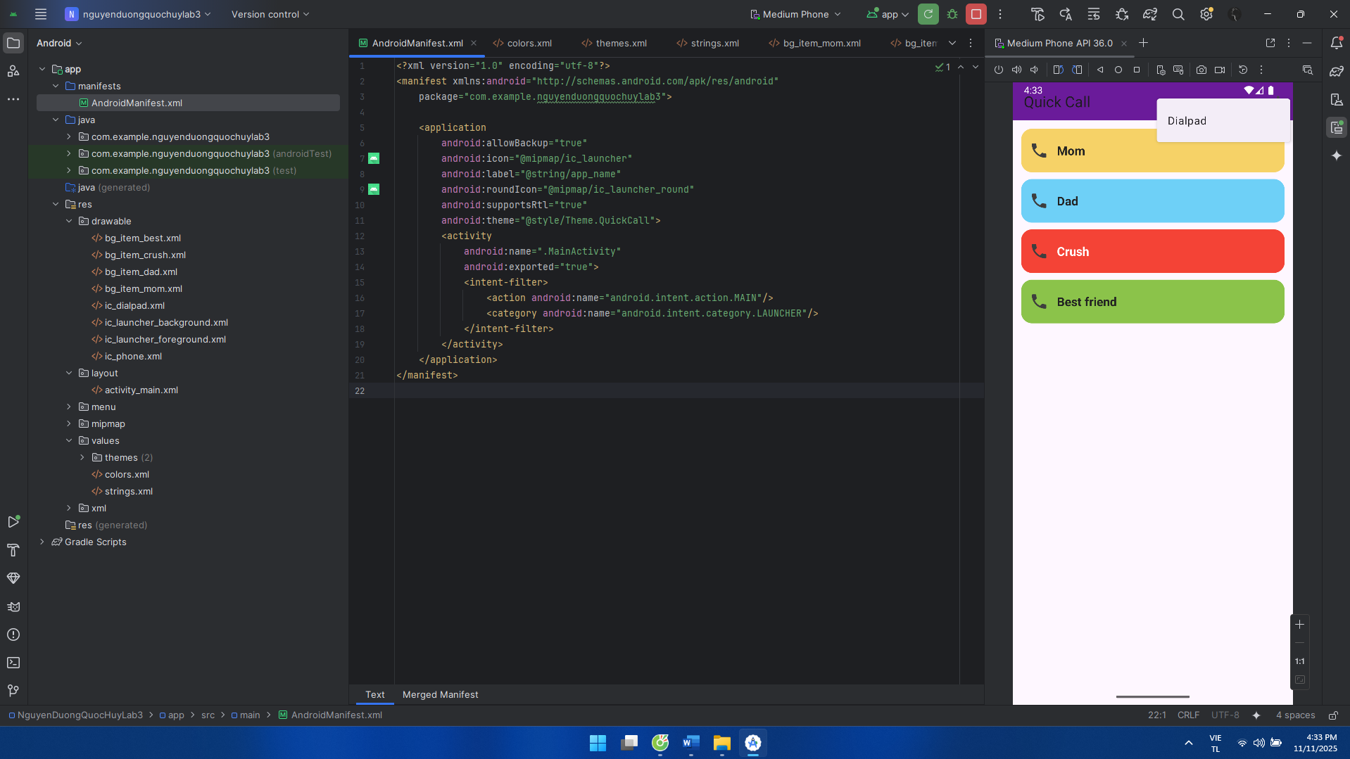

**Bài Tập 1:**

Từ luyện tập 1 chúng ta tiến hành random khi bấm vào voi

Strings:

<resources>  
 <string name="app_name">Face Animation</string>  
 <string name="title">Face Animation</string>  
</resources>

activity_main:

<?xml version="1.0" encoding="utf-8"?>  
<LinearLayout xmlns:android="http://schemas.android.com/apk/res/android"  
 android:layout_width="match_parent"  
 android:layout_height="match_parent"  
 android:orientation="vertical"  
 android:background="@color/bg">  
  
 <TextView  
 android:id="@+id/tvHeader"  
 android:layout_width="match_parent"  
 android:layout_height="56dp"  
 android:background="@color/purple_600"  
 android:gravity="center_vertical"  
 android:paddingStart="16dp"  
 android:text="@string/title"  
 android:textColor="@color/white"  
 android:textStyle="bold" />  
  
 <LinearLayout  
 android:layout_width="match_parent"  
 android:layout_height="0dp"  
 android:layout_weight="1"  
 android:gravity="center">  
  
 <ImageView  
 android:id="@+id/imgFace"  
 android:layout_width="220dp"  
 android:layout_height="220dp"  
 android:src="@drawable/elephant"  
 android:contentDescription="@string/title" />  
 </LinearLayout>  
</LinearLayout>

MainActivity:

package com.example.nguyenduongquochuylab3;  
  
import android.animation.ObjectAnimator;  
import android.animation.PropertyValuesHolder;  
import android.animation.ValueAnimator;  
import android.os.Bundle;  
import android.view.View;  
import android.widget.ImageView;  
  
import androidx.appcompat.app.AppCompatActivity;  
  
import java.util.Random;  
  
public class MainActivity extends AppCompatActivity {  
  
 ImageView img;  
 ObjectAnimator alphaAnim, scaleAnim, transAnim, rotateAnim;  
 final Random rnd = new Random();  
  
 @Override  
 protected void onCreate(Bundle savedInstanceState) {  
 super.onCreate(savedInstanceState);  
 setContentView(R.layout.*activity_main*);  
  
 img = findViewById(R.id.*imgFace*);  
  
 alphaAnim = ObjectAnimator.*ofFloat*(img, View.*ALPHA*, 1f, 0.3f, 1f);  
 alphaAnim.setDuration(900);  
 alphaAnim.setRepeatCount(ValueAnimator.*INFINITE*);  
  
 PropertyValuesHolder sx = PropertyValuesHolder.*ofFloat*(View.*SCALE_X*, 1f, 1.25f, 1f);  
 PropertyValuesHolder sy = PropertyValuesHolder.*ofFloat*(View.*SCALE_Y*, 1f, 1.25f, 1f);  
 scaleAnim = ObjectAnimator.*ofPropertyValuesHolder*(img, sx, sy);  
 scaleAnim.setDuration(900);  
 scaleAnim.setRepeatCount(ValueAnimator.*INFINITE*);  
  
 transAnim = ObjectAnimator.*ofFloat*(img, View.*TRANSLATION_X*, 0f, 60f, -60f, 0f);  
 transAnim.setDuration(1200);  
 transAnim.setRepeatCount(ValueAnimator.*INFINITE*);  
  
 rotateAnim = ObjectAnimator.*ofFloat*(img, View.*ROTATION*, 0f, 360f);  
 rotateAnim.setDuration(1200);  
 rotateAnim.setRepeatCount(ValueAnimator.*INFINITE*);  
  
 img.setOnClickListener(v -> playRandom());  
 }  
  
 private void stopAll() {  
 if (alphaAnim.isRunning()) alphaAnim.cancel();  
 if (scaleAnim.isRunning()) scaleAnim.cancel();  
 if (transAnim.isRunning()) transAnim.cancel();  
 if (rotateAnim.isRunning()) rotateAnim.cancel();  
 }  
  
 private void playRandom() {  
 stopAll();  
 int which = rnd.nextInt(4);  
 switch (which) {  
 case 0: alphaAnim.start(); break;  
 case 1: scaleAnim.start(); break;  
 case 2: transAnim.start(); break;  
 default: rotateAnim.start(); break;  
 }  
 }  
}

Giao diện:

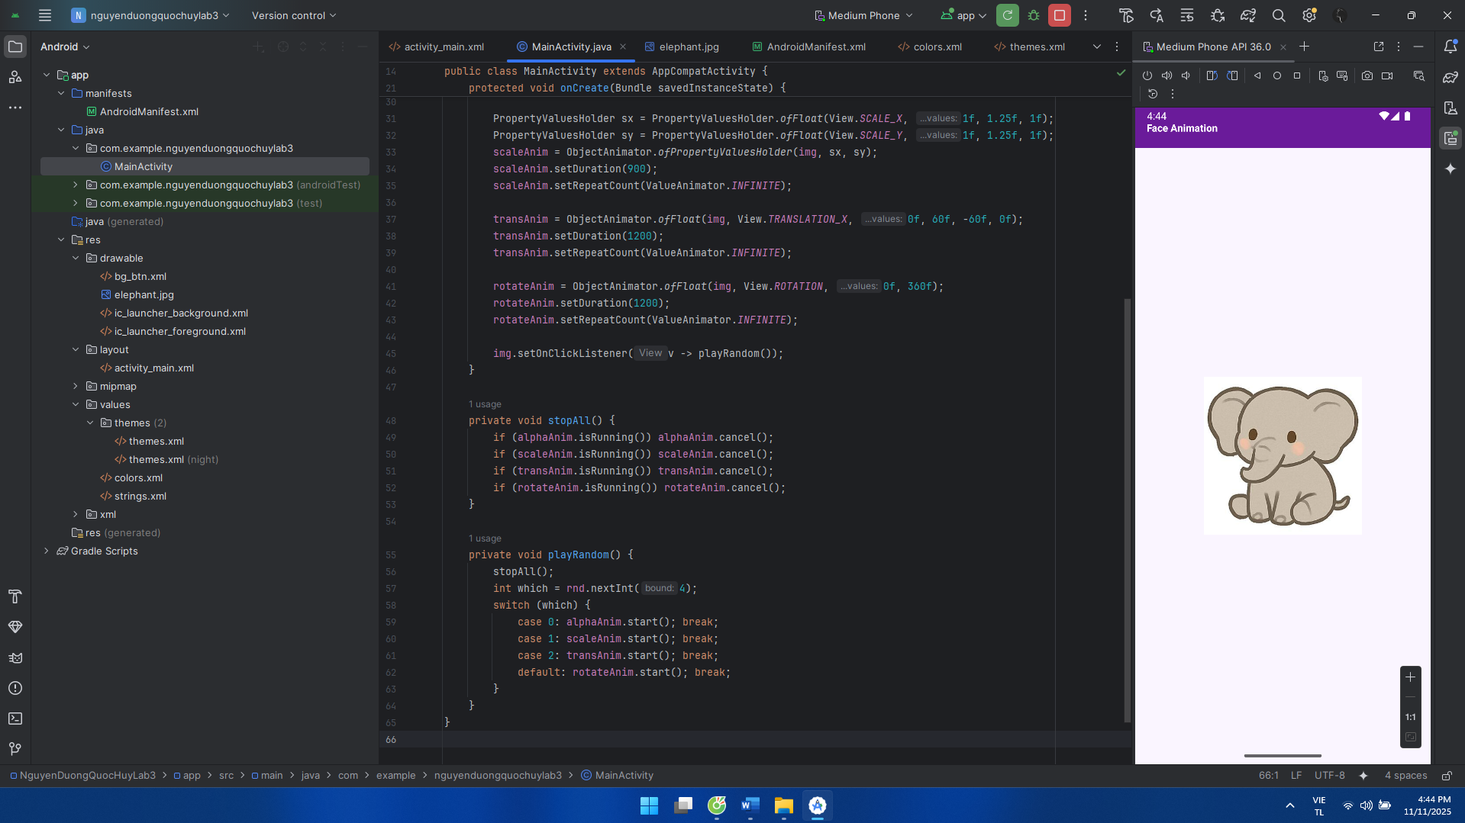

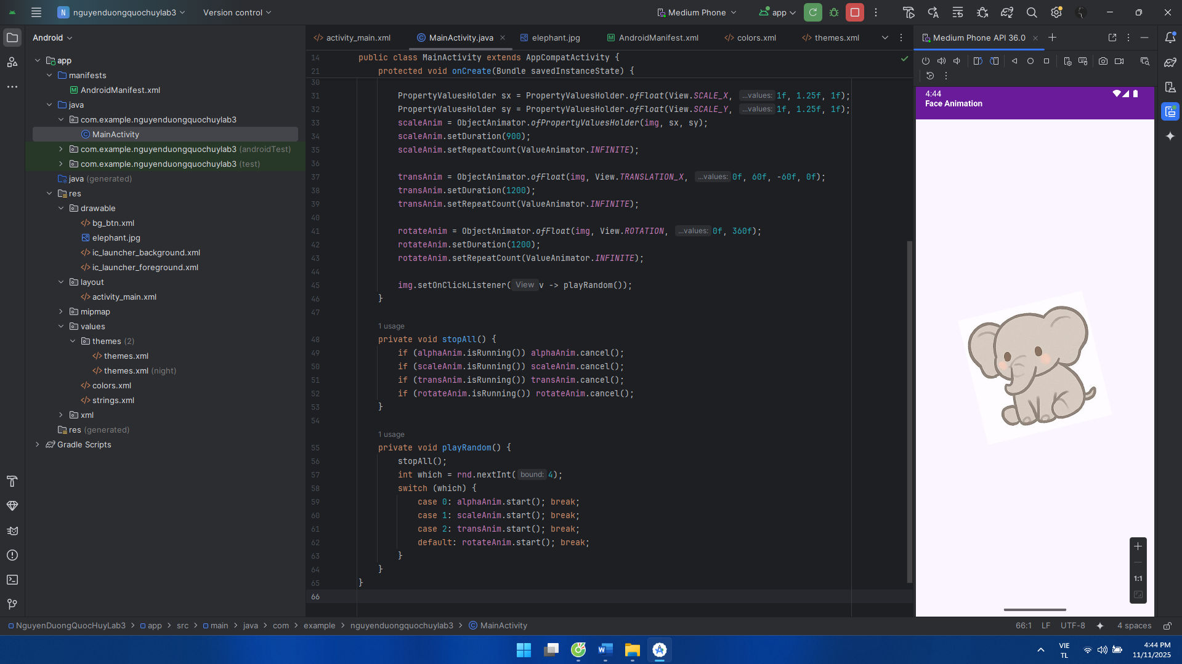

**Bài Tập 2:**

Từ luyện tập 1 chúng ta tiến hành bỏ animation vào luyện tập 2

MainActivity:

package com.example.nguyenduongquochuylab3;  
  
import android.animation.ObjectAnimator;  
import android.animation.PropertyValuesHolder;  
import android.animation.ValueAnimator;  
import android.content.Intent;  
import android.net.Uri;  
import android.os.Bundle;  
import android.view.View;  
import android.widget.LinearLayout;  
  
import androidx.appcompat.app.AppCompatActivity;  
import androidx.appcompat.widget.Toolbar;  
  
public class MainActivity extends AppCompatActivity {  
  
 LinearLayout rowMom, rowDad, rowCrush, rowBest;  
  
 ObjectAnimator animMom, animDad, animCrush, animBest;  
  
 @Override  
 protected void onCreate(Bundle savedInstanceState) {  
 super.onCreate(savedInstanceState);  
 setContentView(R.layout.*activity_main*);  
  
 Toolbar tb = findViewById(R.id.*toolbar*);  
 tb.setTitle(getString(R.string.*title_quickcall*));  
 setSupportActionBar(tb);  
  
 rowMom = findViewById(R.id.*rowMom*);  
 rowDad = findViewById(R.id.*rowDad*);  
 rowCrush = findViewById(R.id.*rowCrush*);  
 rowBest = findViewById(R.id.*rowBest*);  
  
 rowMom.setOnClickListener(v -> dial(getString(R.string.*tel_mom*)));  
 rowDad.setOnClickListener(v -> dial(getString(R.string.*tel_dad*)));  
 rowCrush.setOnClickListener(v -> dial(getString(R.string.*tel_crush*)));  
 rowBest.setOnClickListener(v -> dial(getString(R.string.*tel_best*)));  
  
 animMom = ObjectAnimator.*ofFloat*(rowMom, View.*ALPHA*, 1f, 0.3f, 1f);  
 animMom.setDuration(900);  
 animMom.setRepeatCount(ValueAnimator.*INFINITE*);  
  
 PropertyValuesHolder sx = PropertyValuesHolder.*ofFloat*(View.*SCALE_X*, 1f, 1.12f, 1f);  
 PropertyValuesHolder sy = PropertyValuesHolder.*ofFloat*(View.*SCALE_Y*, 1f, 1.12f, 1f);  
 animDad = ObjectAnimator.*ofPropertyValuesHolder*(rowDad, sx, sy);  
 animDad.setDuration(900);  
 animDad.setRepeatCount(ValueAnimator.*INFINITE*);  
  
 animCrush = ObjectAnimator.*ofFloat*(rowCrush, View.*TRANSLATION_X*, 0f, 40f, -40f, 0f);  
 animCrush.setDuration(1100);  
 animCrush.setRepeatCount(ValueAnimator.*INFINITE*);  
  
 animBest = ObjectAnimator.*ofFloat*(rowBest, View.*ROTATION*, 0f, 360f);  
 animBest.setDuration(1200);  
 animBest.setRepeatCount(ValueAnimator.*INFINITE*);  
  
 rowMom.setOnLongClickListener(v -> { toggle(animMom); return true; });  
 rowDad.setOnLongClickListener(v -> { toggle(animDad); return true; });  
 rowCrush.setOnLongClickListener(v -> { toggle(animCrush); return true; });  
 rowBest.setOnLongClickListener(v -> { toggle(animBest); return true; });  
 }  
  
 private void dial(String telUri) {  
 Intent i = new Intent(Intent.*ACTION_DIAL*, Uri.*parse*(telUri));  
 startActivity(i);  
 }  
  
 private void toggle(ObjectAnimator a) {  
 if (a.isRunning()) a.cancel(); else a.start();  
 }  
}  
Giao diện:

